Federal Procurement Data System – Next Generation (FPDS-NG)

Award/Indefinite Delivery Vehicle (IDV) Training Manual

Prepared by:



Global Computer Enterprises, Inc.
10780 Parkridge Blvd., Suite 300
Reston, VA 20191

Document Change History
Date | Version Number | Submitted By | Change Reference
9/08/2006 | 2 | Riain | Added audit tables
05/07/2007 | 3 | Joan Lobato | Modified and updated the manual with new content, screen captures and new exercises. Reformatted the layout and corrected syles.
Document Approvers*
Version Number | Date Approved | *Approved By | Role/Responsibility
2 | 11/20/2006 | SEPG | Process Improvement Oversight

- *Indicates name of final person authorized by GCE executive management to perform document approval.
- Please note: All GCE process-related documentation must be presented to the GCE Software Engineering Process Group (SEPG) for internal review and approval prior to its upload onto the GCE Process Asset Library (PAL). An approval notification will be emailed to the submitter when the process has been approved. If no approval email is received within 72 hours of submittal, please assume that the process has not been approved.
- For questions or comments, please contact your team’s SEPG Representative or the GCE SEPG Director.
Stakeholders Acceptance Table
Version Number | Date Approved | *Project Stakeholders | Role/Responsibility

*All GCE projects have been reviewed and approved jointly with that project's stakeholders. Project stakeholders are clients and internal (GCE) employees whom have an equal responsibility towards a project's success.
Table of Contents

Section Page
1 Introduction 1
1.1 Manual Layout 1
2 Terminology 2
3 Common System Features 4
3.1 Login Screen 4
3.2 Initial Login Screen 4
3.3 Incorrect Logins 4
3.4 Forgotten Password 5
3.5 Expired Login Session 5
3.6 Navigation Screen 6
3.7 Web Form Toolbar 6
3.8 Search Function 7
3.8.1 PIID Use in Advanced Search 9
3.8.2 Migrated PIIDs 9
3.9 Exercise: Login Screen 11
3.9.1 Log into FPDS-NG 11
4 Awards 12
4.1 Delivery/Task Order Against IDV 13
4.1.1 Create a Delivery/Task Order Against IDV 13
4.2 Purchase Order 31
4.2.1 Create a Purchase Order 31
4.3 Definitive Contract 38
4.3.1 Create a Standalone Contract 38
4.4 BPA Call 44
4.4.1 Create a BPA Call 44
4.5 Awards Inbox 48
4.5.1 Drafts Awards 48
4.5.2 Final Awards 48
4.5.3 Error Awards 48
4.5.4 Unsaved Awards 48
4.5.5 Template Awards 49
4.6 Exercises: Awards 50
4.6.1 Create a Delivery/Task Order 50
4.6.2 Create a Purchase Order 51
4.6.3 Create a DefinitiveContract 53
4.6.4 Create a BPA Call 55
4.6.5 Create a Template for an Award 56
4.6.6 Finalize an Award 57
4.6.7 Make a Correction to a Final Award 57
5 Basic IDVs 59
5.1 FSS 61
5.2 GWAC 61
5.3 BOA 69
5.3.1 Create a BOA 69
• BPA 74
5.3.2 Create a BPA 74
5.4 IDC 78
5.4.1 Create an IDC 78
5.5 IDV Inbox 83
5.5.1 Draft IDVs 83
5.5.2 Final IDVs 83
5.5.3 Error IDVs 83
5.5.4 Unsaved IDVs 83
5.5.5 Template IDVs 84
5.6 Exercise: Basic IDVs 85
5.6.1 Create a GWAC 85
5.6.2 Create a BOA 86
5.6.3 Create a BPA 89
5.6.4 Create an IDC 90
5.6.5 Create a Template for an IDV 92
5.6.6 Finalize an IDV 92
5.6.7 Make a Correction to a Final IDV 93
6 Transactions/Modifications 94
6.1 General Functions of Transactions/Modifications 94
6.1.1 Corrections 94
6.1.2 Modifications 95
6.2 Exercise: Transactions/Modifications 95
6.2.1 Correct a Document 95
6.2.2 Modify a Document 96
7 Reports 97
7.1 General Functions of Reports 97
7.1.1 Add Reports 97
7.1.2 Create Reports 98
7.1.3 Accessing Reports in My Reports 98

List of Tables
Table Page
Table 1. Training Manual Structure 1

List of Figures
Figure Page
Figure 1. General Login Screen 4
Figure 2. Forgotten Password Notification Screen 5
Figure 3. Expired Login Screen 5
Figure 4. Navigation Screen 6
Figure 5. User Management Standard Toolbar 6
Figure 6. Standard Toolbar for Maintenance Screens 6
Figure 7. User Selection Screen 7
Figure 8. User Selection Defined 8
Figure 9. Advanced Search Screen 9
Figure 10. FPDS-NG Login Screen 11
Figure 11. FPDS-NG Navigation Screen 12
Figure 12.. Adding a $50,000 Purchase Order 14
Figure 13. Initial Obligation Screen 15
Figure 14. $5,000 Modification 15
Figure 15. Final Total 16
Figure 16. $100,000 Contract 16
Figure 17. Existing Contract for $200,000 17
Figure 18. Modification to Add $75,000 17
Figure 19. Validated and Approved for $75,000 17
Figure 20. Option for 150,000 17
Figure 21.Validated and Approved for $150,000 18
Figure 22. New Contract with $500,000 in Obligations 18
Figure 23. Modification for $225,000 18
Figure 24. Validate and Approve for $225,000 19
Figure 25. Modification for an Additional $25,000 19
Figure 26. Validated and Approved for $25,000 19
Figure 27. Delivery Order for $50,000 19
Figure 28. Modification Deobligating $5,000 20
Figure 29. Validated and Approved Deobligation for $5,000 20
Figure 30. Incremental Funding 20
Figure 31. Incremental Funding for $100,000 21
Figure 32. Validated and Approved for $100,000 22
Figure 33. Incremental Funding of Mod #2 22
Figure 34. Final Obligation for $100,000 22
Figure 35. Fee Paid Screen 22
Figure 36. Basic IDV Screen 60
Figure 37. Correction Search Screen 94
Figure 39. Modification Search Screen 95
Figure 40. Reports Screen 97

Introduction
This training manual is designed to act as a guide for operating the Award/Indefinite Delivery Vehicle (IDV) functions within the Federal Procurement Data System – Next Generation (FPDS-NG). This manual is used in conjunction with the Award/IDV class. In addition to this training manual, further instruction is available via the following online tools:
- User Guide
- Help System
- Computer Based Training (CBT)

Manual Layout
This training manual provides how-to guides, exercises, and examples that describe FPDS-NG Award/IDV functions and processes. As such, the training manual is a valuable resource tool for agency trainers and other authorized users. Class participants are encouraged to use this manual at their respective work locations as a reference and as a tool for agency in-house training. Table 1 describes the training manual layout and design.
Manual Section | Section Purpose
Overview | Defines and explains the importance of each section.
How To | Provides answers to frequently asked questions with simple, easy to follow instructions.
Examples | Illustrates specific functions to provide understanding for section tasks.
Exercises | Provides a tool for class participants to gain hands-on experience. The course exercises are discussed in class to measure and reinforce the participant’s comprehension.
Table 1. Training Manual Structure
AWARDS/IDV FUNCTIONS
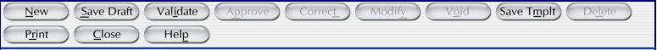

– Creates a new entry screen for either the Award or IDV section.
– Saves the information in your document. Use this when you report data in the system, whether complete or in part.
– Determines if there are any errors. Use this when the record is complete. If there are errors, the screen will display error messages at the top of the document. All fields in error status are shown in Red.
– Allows you to approve the document. Use this when the document is error free. The record will be in final status and reported in FPDS-NG.
– Allows you to fix mistakes in FPDS-NG that do not change the legal intent of the contract action. You can only use this function when a contract action report is in final status.
– Allows you to prepare the modification record. This button is on the header of your entry document. You can also use the Modification selection from the main menu under Transactions/Modifications.
– Allows you to prepare a document to be used as a template for recurring awards.
– Allows you to delete a record entirely from the system. Nothing is saved in FPDS-NG. However, the PIID may be re-used. FPDS-NG will not allow the user to delete a base record if there are modifications or orders against it.
– Allows you to print the document that is currently on the screen. The landscape mode should be used to capture all fields on the document.
– Closes the current document without saving. The user will see a dialog box asking if the document should be saved.
– Provides the user an on-screen help system. A glossary is contained in the help. You can also access the help system after logging in to FPDS-NG (at https://fpds.gov). Click the Help button at the top right corner of the screen.

Terminology
The following section includes terminology that is used in the FPDS-NG system.

Award – A one time request for products or services.
Indefinite Delivery Vehicle (IDV) – An ongoing agreement for products or services.
Procurement Instrument Identifier (PIID) – A unique identifying contract number.
Novation – The action of changing a vendor on a finalized contract.
Inbox – An area on the FPDS-NG Navigation screen where documents associated with the user’s ID are stored according to status.
Draft – The status of a document when it has not been approved and changes can still be made to it manually.
Final – The status of a document when it has been validated and approved. To make changes to a finalized document the user must perform a system-assisted correction or modification.
Approve – A function that compares the document against all of the Business and Validation rules and places it into Final status.
Template – A document which includes pre-populated fields to facilitate data entry. Templates can be created by users to reduce time spent on data entry.
Validation Rules – Rules for validation within the FPDS-NG system that verifies three areas of validation including database integrity, adherence to Business Rules, and population of mandatory fields. Database integrity verifies that codes are valid. Adherence to Business Rules verifies that all the fields that are filled in with information are filled in correctly. Population of mandatory fields verifies that the user has filled out the system-deemed mandatory fields.
Business Rules – Rules that are part of the Validation Rules and verify that all the fields that are filled in with information are filled in correctly.
Lookups – A tool in the system that takes the form of button that the user can select to auto-populate a field. Selecting the lookup button opens a search screen which can be used to choose what information should go in the field.
CCR Exception – The Central Contract Registry (CCR) is a database of all the contractors that are registered to do business for the government. Vendors not registered with CCR cannot generally be reported on government contracts. CCR Exceptions provide a way for exempt contractors to provide business to the government.
NAICS Code – The North American Industry Classification System (NAICS) codes designate major sectors of the economies of Mexico, Canada, and the United States.
PSC – A product or service code that best identifies the product or service procured. Codes are defined in the Product and Service Codes Manual.
Batch Processes – A Flat file format used for submitting multiple documents into the FPDS-NG system.
Delete –Deleting an item completely removes it from the system.
Funding Agency/Office – Referred to as the government office/agency, this office/agency is responsible for providing the funds for the award or IDV.

Common System Features

Login Screen
Agency System Administrators create user IDs and passwords for their respective agency. FPDS-NG users are provided access to Awards, IDV, System Administration, and Report features associated with the system privileges and user types assigned. The user accesses an initial login screen and enters a user ID and password.

Initial Login Screen
The Login screen, shown in Figure 1, is the initial screen provided for FPDS-NG users. To log into FPDS-NG, the user enters their user ID, password, and select. A successful login opens the Navigation screen shown in Figure 4.
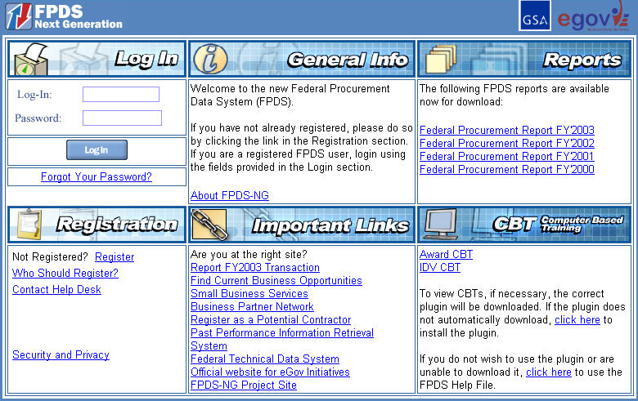
Figure 1. General Login Screen

Incorrect Logins
If the user enters an incorrect password, the FPDS-NG Login screen allows the user three attempts to enter the correct password.

Forgotten Password
If the user has forgotten his/her password, it can be recovered by following the 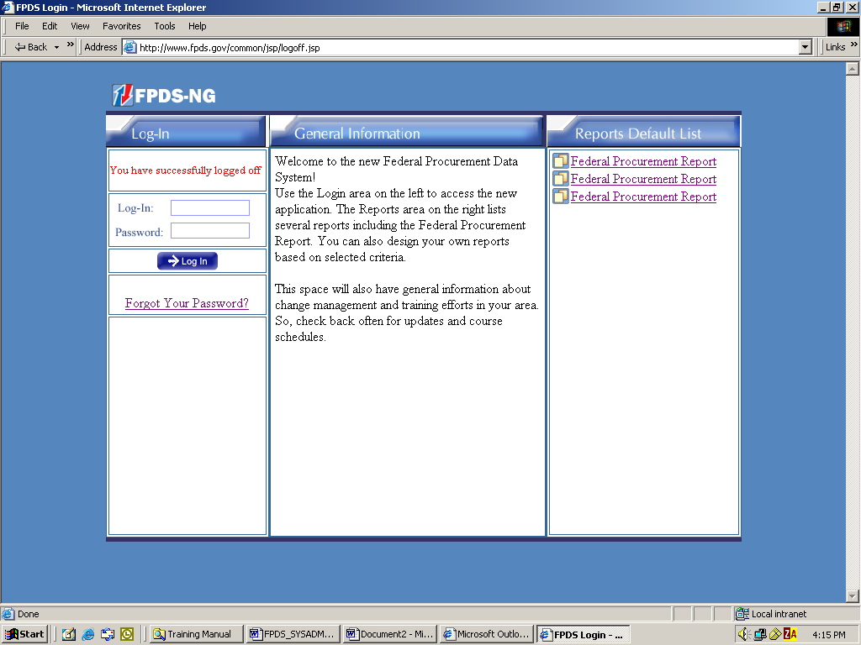 link. This displays the screen shown in Figure 2. The user enters his/her user ID, and then selects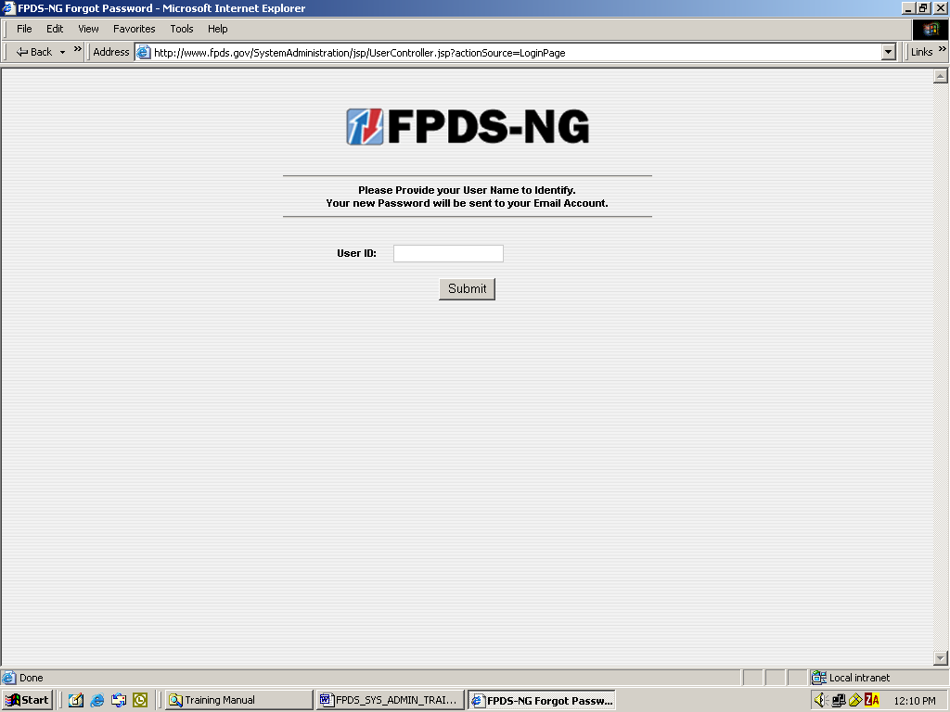. Once the user ID has been submitted, the Forgotten Password feature will email the user a new login password.
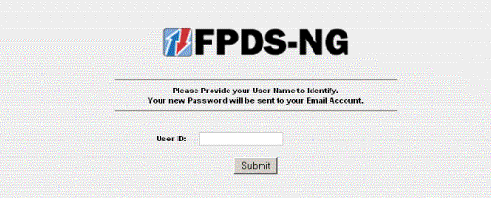
Figure 2. Forgotten Password Notification Screen

Expired Login Session
After a period of inactivity, approximately 30 minutes, FPDS-NG will automatically end the user’s session. If the user needs to restart the session, a second login screen is provided. This is the Expired Login screen and is illustrated in Figure 3. The user must re-enter his/her user name and password, and then select. On a successful login, FPDS-NG opens to the Navigation screen. See Figure 4.
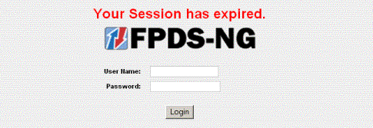
Figure 3. Expired Login Screen

Navigation Screen
The FPDS-NG Navigation screen shown in Figure 4 is organized in five sections: Awards, Basic IDVs, Transactions/Modifications, System Administration, and Reports. Each section contains a list of tasks related to the section. Each task links to a specific Web-based form on which users enter and submit data.
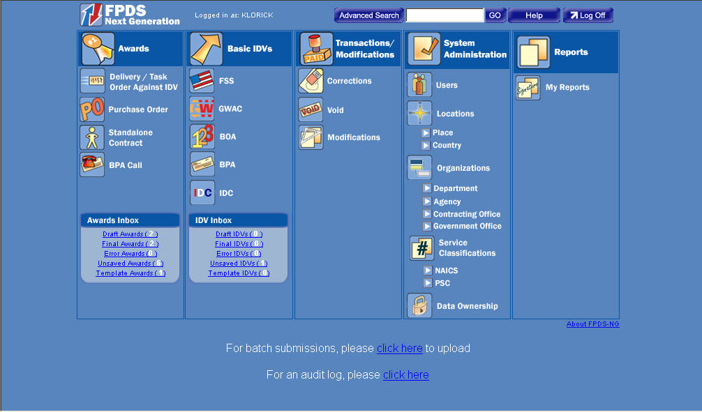
Figure 4. Navigation Screen

Web Form Toolbar
Search functions are available throughout the System Administration section in FPDS-NG. These functions are used to access users, locations, organizations, service classifications, etc. A standard toolbar, similar to the one depicted in Figure 5, is available for each Web form. For example, the toolbar displayed below is located at the top of the Users screen.
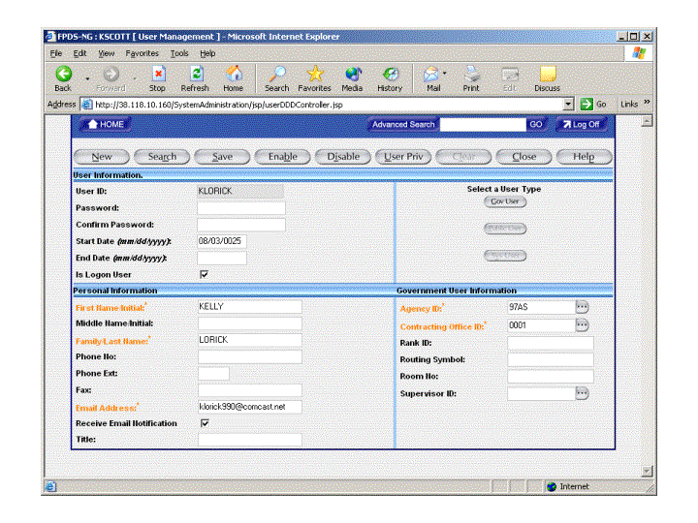
Figure 5. User Management Standard Toolbar
The toolbar shown in Figure 6 is located at the bottom of Locations, Organizations, and Service Classifications maintenance screens.
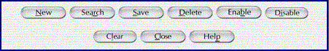
Figure 6. Standard Toolbar for Maintenance Screens

Search Function
One feature common to most Web forms in FPDS-NG is the Search function. For example, to search for users in the Web forms, select located on the standard toolbar shown in Figure 5. The Search function is available for all System Administration tasks.
Using the Search Function
- From the Navigation screen, under System Administration, select.
- Select located at the top of the User Management screen on the standard toolbar.
- The User Selection screen is displayed, as shown in Figure 7.
- Select 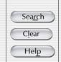 on the bottom right corner of the screen. The fields are now blank.
- In the User ID field, located in the lower left corner of the screen, type in a user ID
- Select located in the lower right corner of the screen.
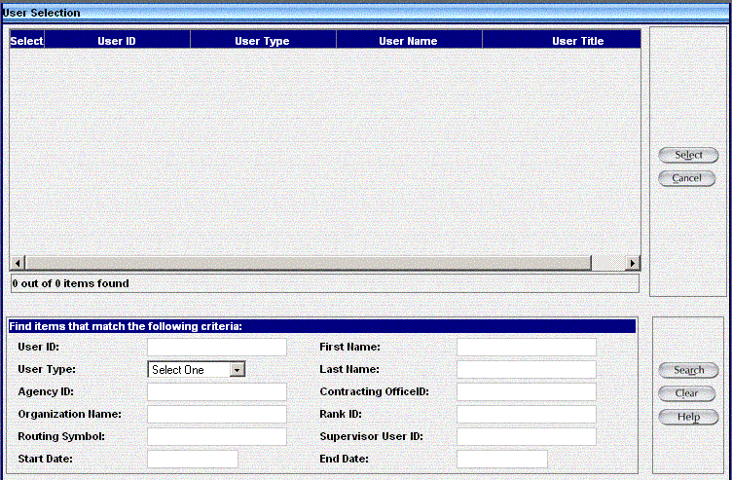
Figure 7. User Selection Screen
- Information based on the search criteria provides a list of user IDs which are displayed in the User Selection screen, shown in Figure 8.

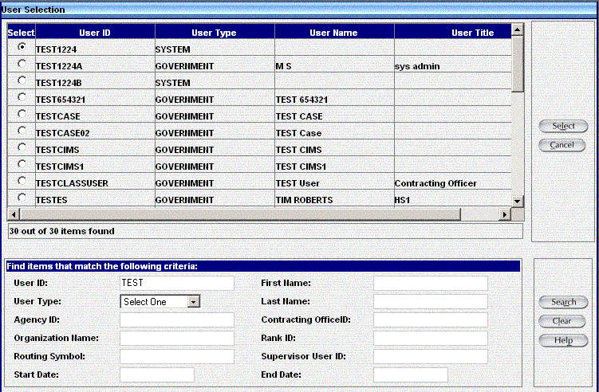
Figure 8. User Selection Defined
- To obtain the user associated with the search criteria, selectlocated in the Select column shown in Figure 8.
- After selecting the user, click located in the right top corner, to open the User Selection information.
Note: Fewer search criteria will produce more results, however, to search the list of users without using a criteria selection, leave all fields blank in the search area shown at the bottom of Figure 8, then select. When the matching criteria fields are empty, the generated list contains a larger selection of users.
Note: Due to the volume of data in FPDS-NG, the selection results are limited to a portion of the data available, such as the first 200 records. It is recommended that you always enter search criteria to narrow the selection when possible.

PIID Use in Advanced Search
When performing an advanced search, a PIID number can be used. The PIID number can be found on the Advanced Search screen illustrated in Figure 9.
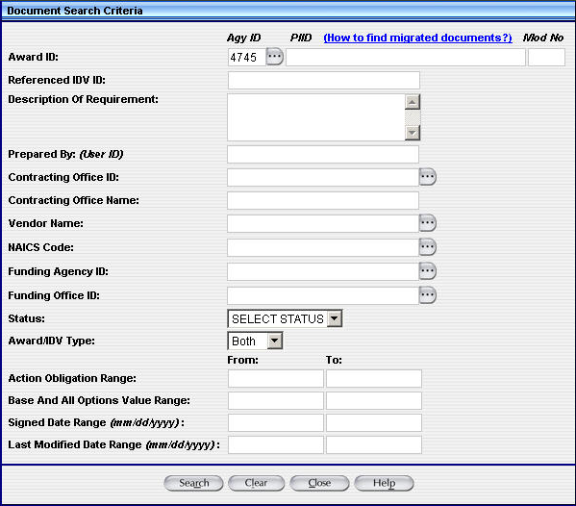
Figure 9. Advanced Search Screen

Migrated PIIDs
For migrated IDVs, the PIID is the same as the original contract number. For migrated awards, the PIID is a combination of the following:
  - Contracting Office Code
  - Action Date (format "YYYYMM")
  - Contract Action Type (A, B, C, D)
  - Order Number (if it exists)
  - Contract Number
The formula used for the PIID number can be used to perform an advanced search. For example, to find a Delivery Order created in October 1995 with:
- Agency – U.S. Coast Guard (6950)
- Contracting Office – 23
- Order Number – DTCG2394FTACX01
- Contract Number – DTCG2391DTTMB12
The PIID would be calculated by the following:
- "00023" (Contracting Office ID with leading zeroes)
- +"199510" (Action Date in YYYYMM format)
- +"C" (Contract Action type - Delivery Order)
- +"DTCG2394FTACX01" (Order Number)
- +"DTCG2391DTTMB12" (Contract Number)
The PIID would equal 00023199510CDTCG2394FTACX01DTCG2391DTTMB12.

Note: The PIID Number format must be uppercase, alphanumeric with no embedded spaces or special characters. FPDS-NG will convert lowercase letters to uppercase, remove leading or trailing blank spaces, and remove any non-alphanumeric characters prior to validation.
Note: The Contract Action type is a single character representing the award type.

Exercise: Login Screen

Log into FPDS-NG
The Login screen shown in Figure 10 is used to sign in to FPDS-NG. To begin the course exercises, follow the steps below and log in to FPDS-NG.
- To open FPDS-NG go to the URL provided by the instructor and enter the following information to display the Navigation screen.
- Login: Enter the user ID provided by the instructor.
- Password: Enter the password providedby the instructor..
- Select to display the Navigation screen in FPDS-NG.

Figure 10. FPDS-NG Login Screen

Awards

AWARD COLUMN
An award is a contractual vehicle that cannot have orders placed against it. Use this column when entering the following types of documents:
Awards are accessed via the Navigation screen of the FPDS-NG system as shown in Figure 11. The Awards module allows the user to add and modify awards. Awards are divided into the following four types:

- Delivery/Task Order Against IDV
- Purchase Order
- Definitive Contract
- BPA Call

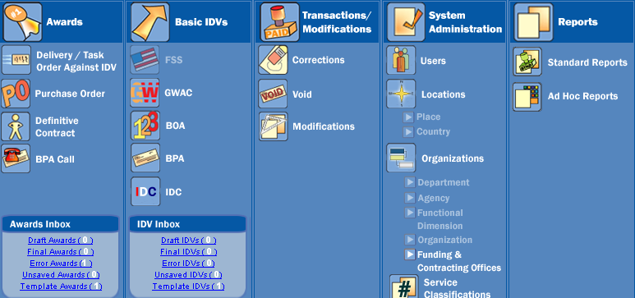
Figure 11. FPDS-NG Navigation Screen

Delivery/Task Order Against IDV

A Delivery/Task Order is used to order supplies placed against an established contract or with government sources.

Create a Delivery/Task Order Against IDV
- From the FPDS-NG Navigation screen, under the Awards section, select.
- FPDS-NG displays the Delivery/Task Order Contract screen ready for data entry.
- Transaction Information section.
  - Award Type – The award type defaults to Delivery/Task Order.
  - Award Status – The award status defaults to New.
  - Prepared User – The Prepared By field defaults to the user ID of the person logged in to FPDS-NG.
  - Prepared Date - The Prepared Date field defaults to the current date.
  - Last Modified Date – The Last Modified By and Last Modified Date field are system generated when the document is updated and saved.
- Document Information section
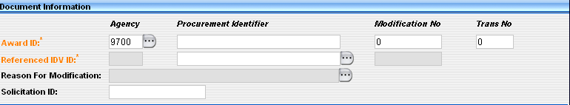
  - Award ID – Enter the Agency ID associated with the FIPS 95 code specified for the agency.
  - PIID No. – Enter the PIID number (Contract, PO, or Agreement number) for the Delivery/Task Order.
Note: The PIID Number format must be uppercase, alphanumeric with no embedded spaces or special characters. FPDS-NG will convert lowercase letters to uppercase, remove leading or trailing blank spaces, and remove any non-alphanumeric characters prior to validation.
Note: The Contract Action type is a single character representing the Award Type. Refer to Section 2.8.1 for the PIID and contract action search functions.
Mod No. – Enter a modification number if the contract is being modified. The Mod No. field defaults to zero.
Trans No. – This field is required for DOD when completing multiple reports on a single contract.
Reference IDV ID – Enter the Reference PIID in the General Information section using the contract or agreement number of the IDV against which the order is placed.
Reason for Modification – Enter a reason for modification if this is a final contract that will be modified. The Reason for Modification dropdown menu is available when a modification number is changed from zero and the document is saved.
Solicitation ID – Enter the Solicitation ID used to link transactions in FPDS-NG to solicitation information. The Solicitation ID (Identifier) is taken from FedBizOpps. The number format must be uppercase, alphanumeric with no embedded spaces or special characters. This field holds a maximum of 25 characters. FPDS-NG will convert lowercase letters to uppercase, remove leading or trailing blank spaces, and remove any non-alphanumeric characters prior to validation.
- Date and Amounts section.
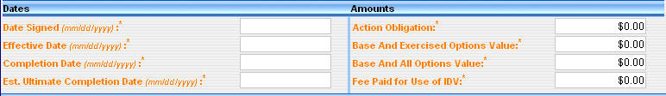
Date Signed – Enter the date the transaction was signed in the Date Signed field. This field represents the date on which a mutually binding agreement was reached. For a bilateral transaction, use the most recent date signed by the Contractor or the Contracting Officer. For a unilateral transaction, use the date on which the agreement was signed by the Contracting Officer.
Effective Date – Enter an effective date agreed to by the parties. The date that the parties agree will be the starting date for the contract’s requirements. Usually this is the same as the date the contract is signed. However, there are some cases where the date is not the signed date. For example, the effective date may be delayed to avoid major holidays or to coincide with the availability of funds; it may be predated to recognize that the contractor started work before the formal agreement was signed.
Completion Date – Enter the completion date for the mutually agreed upon time of completion for the contract including all options or other modifications.
Estimated Completion Date – Enter the mutually agreed upon contract completion date for the entire contract or order including all options or other modifications. For a Delivery Order, this refers to the Delivery Order completion only, not the referenced IDV.
Est. Ultimate Completion Date - This field represents the estimated or scheduled completion date, including the base contract or order and all options (if any) whether the options have been exercised or not. It is the same as the period of performance end date when there are no options. For delivery orders, this refers to the delivery order completion only, not the referenced indefinite delivery vehicle.
This field is required for definitive contracts, delivery orders, modifications, and purchase orders exceeding $25,000. This field is optional for purchase orders equal to or less than $25,000. REPORTING DOLLAR AMOUNTS IN FPDS-NG
Check your agency policy for reporting zero dollar actions. When zero dollar Modifications are reported, the system automatically defaults to $0.00.
The following examples are scenarios for completing the dollar fields in FPDS-NG.
EXAMPLE 1: ADDING A $50,000 PURCHASE ORDER
In Figure 12, the user is reporting a purchase order for $50,000 in FPDS-NG.
Figure 12.. Adding a $50,000 Purchase Order
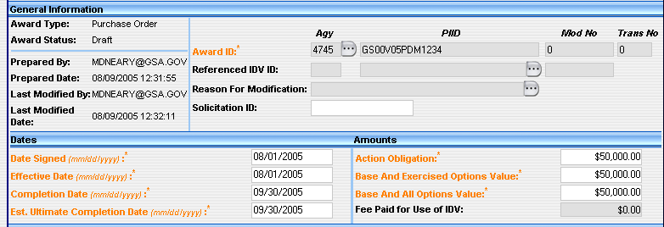
Action Obligation | Input $50,000.00
Base and Exercised Options Value | Input $50,000.00
Base and all Options Value | Input $50,000.00
EXAMPLE 2: REPORTING A $5,000 MODIFICATION
In this example, the user is reporting a $5,000 modification to the original $50,000 purchase order in FPDS-NG. Figure 13 shows the purchase order that was selected for modification.
Figure 13. Initial Obligation Screen
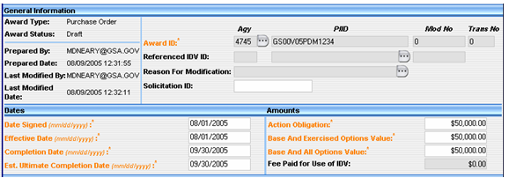
Figure 14 shows an obligation of $5,000.00 entered in the Current column. The Total column will continue to reflect the previous amount until Save Draft is selected.

Figure 14. $5,000 Modification
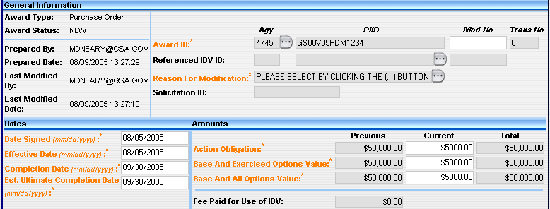
Action Obligation | Input $5,000.00
Base and Exercised Options Value | Input $5,000.00
Base and all Options Value | Input $5,000.00
When the document is saved, validated and approved, the final screen shown in Figure 15 will reflect the new total of $55,000.
Figure 15. Final Total
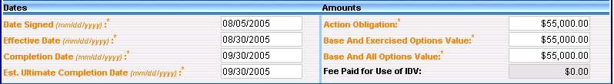

EXAMPLE 3: NEW $100,000 CONTRACT
This example shows a new contract for $100,000 with four one-year options at $125,000 each year. The initial award is a $100,000 obligation. The Base and Exercised Options Value also shows $100,000, while the Base and All Options Value shows the total of $600,000.
Figure 16. $100,000 Contract
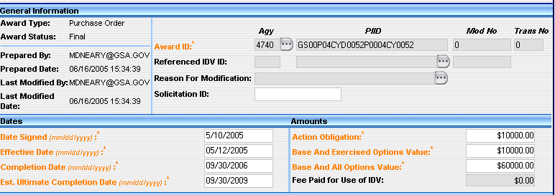
Action Obligation | Input $10,000.00
Base and Exercised Options Value | Input $10,000.00
Base and all Options Value | Input $60,000.00

EXAMPLE 4: EXISTING CONTRACT FOR $200,000
Figure 17 shows an existing contract awarded for $200,000 with Base and All Options totaling $425,000.
Figure 17. Existing Contract for $200,000
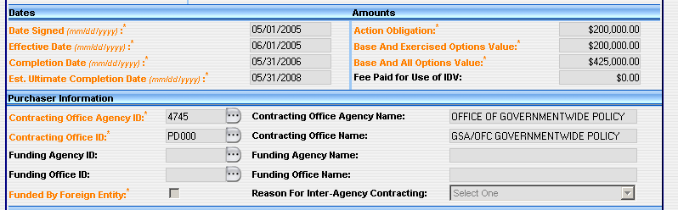
Figure 18 shows a new work modification for $75,000 that also has a required completion date earlier than the base Ultimate Completion Date.
Figure 18. Modification to Add $75,000
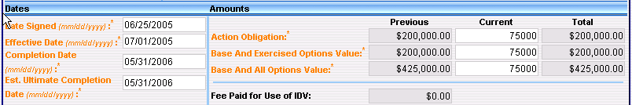
When the document is saved, validated, and approved the final screen shown in Figure 19 will reflect the new total obligation and current value of $275,000. This modification also increases the Base and All Options Value to $500,000.
Figure 19. Validated and Approved for $75,000
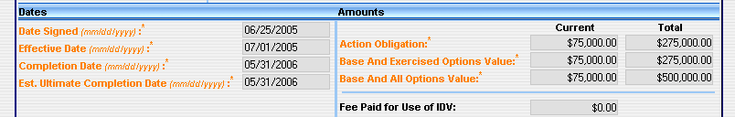
EXAMPLE 5: CREATING A MOD TO EXERCISE AN OPTION YEAR
Figure 20 shows an example of creating a Mod to Exercise an Option Year in the amount of $150,000.
Figure 20. Option for 150,000
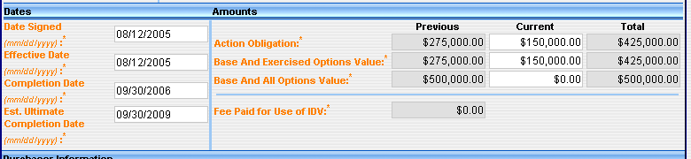
When the document is saved, validated and approved, the final screen shown in Figure 21 will reflect the new total obligation and current value of $425,000.

Figure 21.Validated and Approved for $150,000
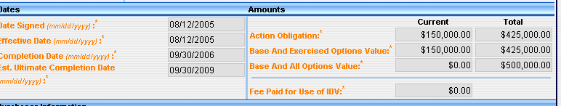
Action Obligation | Input $150,000.00
Base and Exercised Options Value | Input $150,000.00
Base and all Options Value | Input $0.00

EXAMPLE 6: ISSUING MODIFICATIONS FOR $225,000/$25,000
Figure 22 shows a construction contract awarded for $500,000.
Figure 22. New Contract with $500,000 in Obligations
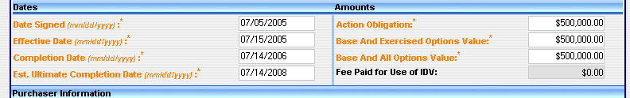
Action Obligation | Input $500,000.00
Base and Exercised Options Value | Input $500,000.00
Base and All Options Value | Input $500,000.00
Figure 23 shows the user issuing a modification in the amount of $225,000.
Figure 23. Modification for $225,000
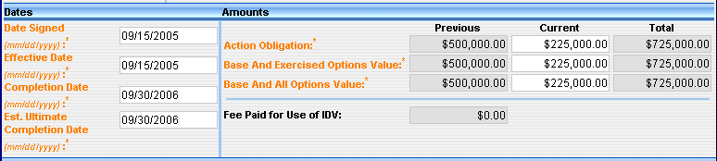
After creating the modification for $225,000 the user has validated and approved the modification in Figure 24.
Figure 24. Validate and Approve for $225,000
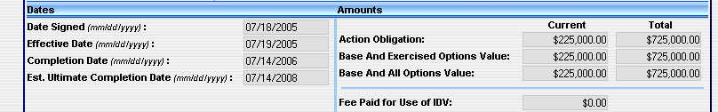
An additional modification for $25,000 is added to the existing total obligated value of $725,000 for a new total of $750,000 in Figure 25.
Figure 25. Modification for an Additional $25,000
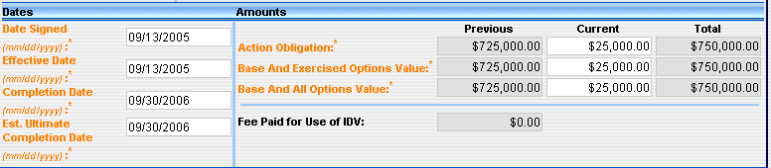
After creating the modification for $225,000 the user has validated and approved the modification in Figure 26.
Figure 26. Validated and Approved for $25,000
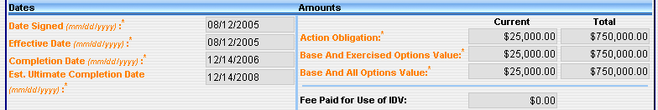

EXAMPLE 7: MODIFICATION DEOBLIGATING $5,000
Figure 27 shows a delivery order for $50,000.
Figure 27. Delivery Order for $50,000
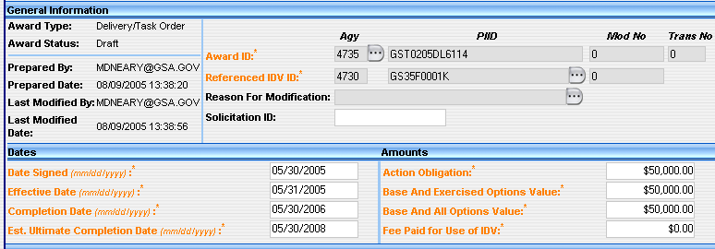
Figure 28 shows the modification deobligating $5,000.00.
Figure 28. Modification Deobligating $5,000
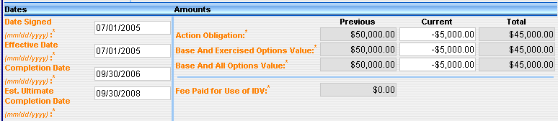

Figure 29 shows the results of a $5,000.00 deobligation in the delivery order amount.
Figure 29. Validated and Approved Deobligation for $5,000
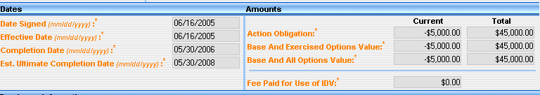

EXAMPLE 8: INCREMENTAL FUNDING
Figure 30 through Figure 34 are examples of Incremental Funding. The contract is for one year, and the Base and All Options Value is $500,000. The initial obligation is $200,000 with incremental funding of $100,000. Figure 22 shows $200,000 obligated at the time of award with the Base and All Options Value of $500,000.
Figure 30. Incremental Funding
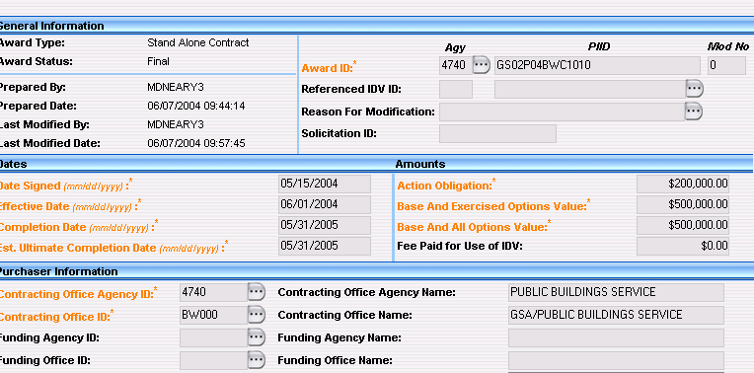
Figure 31 and shows the first incremental obligation of $100,000 after initial award obligation.
Figure 31. Incremental Funding for $100,000
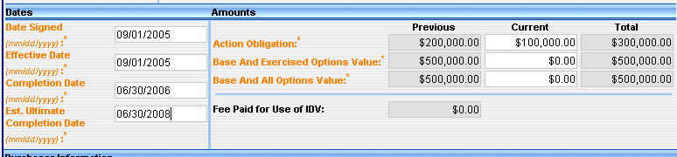

Figure 32. Validated and Approved for $100,000
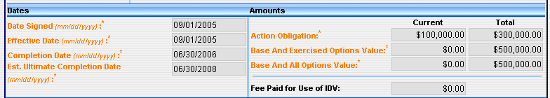

Figure 33 shows the second obligation of $100,000.
Figure 33. Incremental Funding of Mod #2
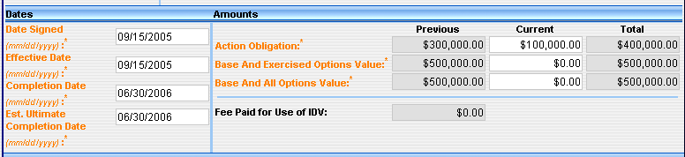
Figure 34 shows the final $100,000 obligation against the contract.
Figure 34. Final Obligation for $100,000
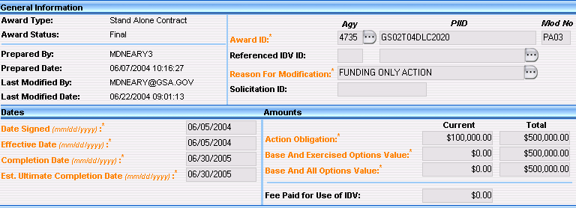
FEE PAID FOR USE OF IDV [R]
The agency placing the order will enter the dollar value of the fee charged for this action. This is only required on delivery orders and BPA calls.
Figure 35. Fee Paid Screen

Action Obligation – Enter the net amount of funds (in dollars and cents) obligated or de-obligated by this transaction. If the net amount is zero, enter zero. If the net amount is a de-obligation, enter a minus sign in addition to the net amount.
Base and Exercised Options Value – Enter the total value (in dollars and cents) of the base contract plus any options that have been exercised at the time of award.
Base and All Options Value – Enter the mutually agreed upon total estimated contract or order value (in dollars and cents) including the base contract and any options.
Fees Paid For Use of IDV – List of administrative fees charged for using an IDV other than a Federal Supply Schedule (FSS). The fees can be one of the following:
1. Fixed
2. Range - Varies by amount
3. Range - Varies by Other Factors
- Purchaser Information section.
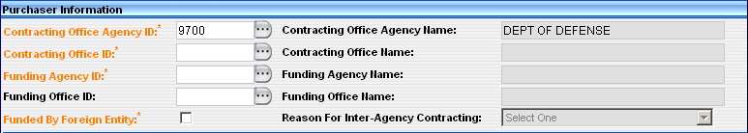
  - Contracting Office Agency ID – This field defaults from the user’s profile.
  - Contracting Office Agency Name – This field defaults from the user’s profile. This field identifies the agency name associated with the FIPS Pub. 95 code used for the contracting office agency ID.
  - Contracting Office ID – Contracting Office ID must be a valid contracting office code in the FPDS-NG Contracting Office/Funding Office Lookup Table for the agency. If the default code is not appropriate, enter the code for the contracting office that executed or is otherwise responsible for the transaction.
  - Contracting Office Name – FPDS-NG completes this field after the contracting office agency ID is entered. This field identifies the agency name associated with the FIPS Pub. 95 code used for the Contracting Office ID.
  - Funding Agency ID – Enter the 4-6 character alphanumeric office code if applicable. Program/Funding Agency Code must be in the FPDS-NG FIPS 95 Agencies/Sub-agency Look-up table. If the default code is not appropriate, enter the code for the funding agency that executed or is otherwise responsible for the transaction.
  - Funding Agency Name – FPDS-NG completes this field after the Funding Agency ID is entered. This field identifies the agency name associated with the FIPS Pub. 95 codes.
  - Funding Office ID – Enter the 4-6 character alphanumeric office code if applicable. This field can be left blank or must be a valid funding office code selected from the FPDS-NG Government Office section. If Program/Funding Agency is DoD, then Program/Funding Office Code must have a value.
  - Funding Office Name – FPDS-NG completes this field after the Funding Office ID is entered. This field identifies the funding office name associated with the FIPS Pub. 95 codes.
  - Funded by Foreign Entity – If a foreign government or international organization bears some of the cost of the acquisition (this includes Foreign Military Sales), select this field. Otherwise leave blank.
  - Reason for Inter-Agency Contracting – When the contracting agency or the funding agency is DoD and this procurement is for computer hardware or services, select a value for the reason certified by the funding office. Reason for purchase must be a valid value from the FPDS-NG Data Dictionary. If Program/Funding Agency Code is DoD and the Product or Service Code begins with ’70,’ ‘D3,’ ‘H170,’ ‘H270,’ ‘H370,’ ‘H970,’ ‘J070,’ ‘K070,’ ‘L070,’ ‘N070,’ ‘U012,’ or ‘W070,’ then reason for purchase must not be blank.
- Contractor Information and Socio Economic Data section.
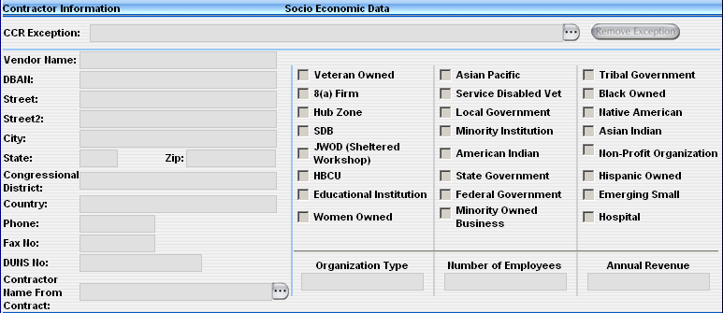
  - CCR Exceptions – This field is not available on the delivery task order. The Vendor information is populated from the referenced IDV.
DUNS NUMBERS [R]
NOTE: You must have a DUNS number or you cannot complete a contract action report in FPDS-NG.
All vendor entries in FPDS-NG must have a DUNS number. There are two types of DUNS numbers, Individual or Vendor DUNS numbers, and Generic DUNS numbers.
- Individual or Vendor DUNS Numbers - The vendor obtains a DUNS through Dun and Bradstreet and enters it into CCR. Contracting officers may obtain DUNS numbers for a vendor but FPDS-NG requires the vendor to enter its information into CCR before a contract award is made.
  - Generic DUNS -There is a small subset of Generic DUNS registered with Dun and Bradstreet and CCR which you may use under the specific circumstances for that generic DUNS, such as “GPC (Government Purchase Card) Small Business”. This allows individuals to process Express reports. When you use a generic DUNS, FPDS-NG will populate the vendor name and address related to that generic DUNS.
  - Name – This field is system populated from the referenced IDV.
  - Socio Economic Data – This section is system populated from the referenced IDV.

- Contract Data section.
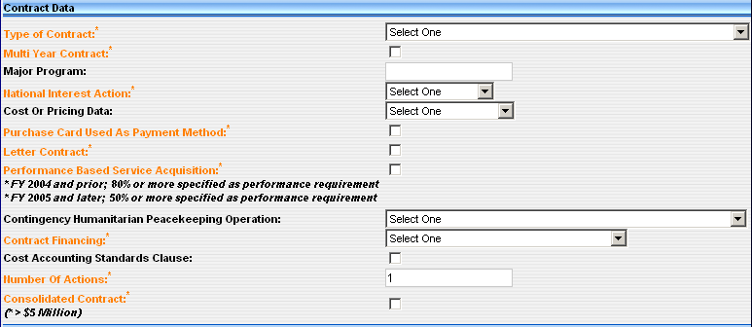
Type of Contract – Select the Type of Contract pricing for this award.
Multi Year Contract – Select the checkbox when the definition for multiyear contract applies. Do not report contracts containing options as multiyear unless the definition below applies to the contract.
Note: A multiyear contract is a contract for the purchase of supplies or services for more than one, but not more than five program years. Such contracts are issued under specific congressional authority for specific programs.
Note: The key distinguishing difference between multiyear contracts and multiple year contracts is that multiyear contracts buy more than one year's requirement (of a product or service) without establishing and having to exercise an option for each program year after the first.
Major Program – If your agency has designated Major Programs and this award is part of such a program, enter the code for the Major Program for this award.
National Interest Action - This field identifies the awards made in response to national interest actions. The actions included in this list are determined by statute or executive order. Select the appropriate national emergency entry from the drop down menu for awards made for the direct assistance or support of victims
Cost or Pricing Data - This is mandatory for DOD, and optional for civilian agencies. Select from the drop-down list the code that indicates whether cost or pricing data was obtained and certified, not obtained or waived. (DFAR 253.204-70(c)(4)(xi))
Purchase Card Used as Payment Method – If the method of payment under an Award is the Purchase Card, select the checkbox.
Letter Contract - Check the box if the award is a Letter Contract. Otherwise, leave blank.
Performance Based Service Contract (PBSC) – A PBSC describes the requirements in terms of results required rather than the methods of performance of the work. Choose from the dropdown menu to indicate if this is a contract for services and 80% or more of the requirement is specified as a performance requirement, if this is a contract for services and less than 80% of the requirement is specified as a performance requirement, or if this is not applicable.
Contingency Humanitarian Peacekeeping Operation – If the award supports a contingency, humanitarian, or peacekeeping operation, then enter the appropriate code. The codes designate contract actions that exceed $200,000 and support a contingency operation, a humanitarian operation, or a peacekeeping operation. Otherwise, leave blank.
Contract Financing – Enter the code that best indicates whether or not progress payments, advance payments, or other financing methods were used. Contract Financing reflects the type of financing used to effect payment.
  - Cost Accounting Standards - This field is Mandatory for DOD, optional for civilian agencies. This field indicates whether the contract includes a Cost Accounting Standards clause. Check the box if the contract includes the Cost Accounting Standards clause. Otherwise, leave blank.

  - Number of Actions - Enter the number of actions. This is an optional field indicating the number input by the user identifying the number of actions that are reported in one transaction, when multiple actions are reported using Express Reporting. If left blank FPDS-NG defaults to the value of one.
  - Consolidated Contract - Select the box if the funding agency or contracting agency is DOD and the contract is for a consolidated requirement. Otherwise, leave blank. Do not check if Bundled Contract is selected
- Legislative Mandates and Principle Place of Performance section.
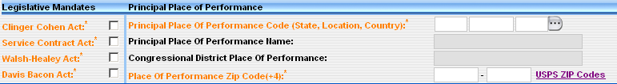
- Clinger Cohen Act – Select this box if the transaction is subject to the Clinger Cohen Act, otherwise leave blank. Selecting this box tracks the acquisitions, use, and disposal of information technology by the Federal Government.
  - Service Contract Act - Check the box if the award is subject to the Service Contract Act and the Service Contract Act clause and wage determination or the collective bargaining agreement is included in the award. Otherwise, leave the box blank. (FAR 22.10)
  - Walsh Healy Act - Check the box if the award is subject to the Walsh Healey Act and the Walsh Healy Act clause is included in the award. Otherwise, leave blank. (FAR 22.6)
  - Davis Bacon Act - Check the box if the award is subject to the Davis Bacon Act and the Davis Bacon Act clause and wage determination or the collective bargaining agreement is included in the award. Otherwise, leave blank. (FAR 22.403-1)
- Principal Place of Performance section.
  - Principal Place of Performance Code – The Principle Place of Performance indicates the location where the majority of work will be performed.
  - Principal Place of Performance Name – This is the name that corresponds with the code entered for the location where the majority of work will be performed.
  - Congressional District Place of Performance - FPDS-NG auto-populates this field based on the information provided in the Place of Performance Zip Code (+4) below.

  - Place of Performance Zip Code (+4) - Complete this field as it is required on all awards. FPDS-NG provides a link to the United States Postal Service website if you do not know the four digit extension to the place of performance zip code. You must complete this field in order for FPDS-NG to generate the Congressional District for the Place of Performance.

- Product or Service Information section.
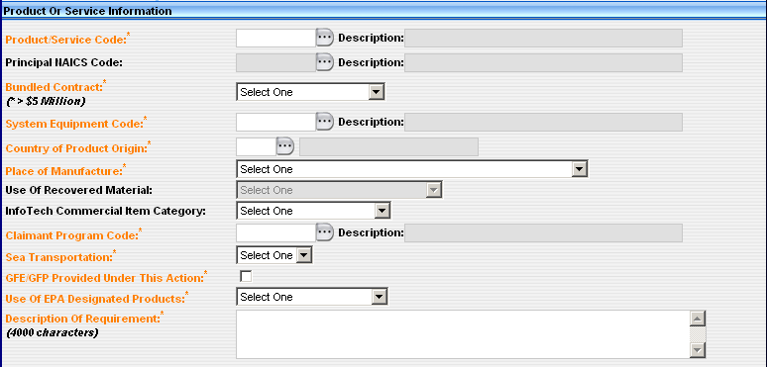
  - Product or Service Code – Select the code that best identifies the product or service procured. If more than one code applies, then report the code that represents most of the ultimate contract value.
Principal NAICS Code - Enter the NAICS Code or use the ellipses button on the screen to find the appropriate NAICS Code. Report the 6-digit code from the North American Industry Classification System (NAICS) Manual. If more than one code applies, report the code that best identifies the product or service acquired and represents the predominance of the dollars obligated or deobligated for the contract/action. The Product or Service Code (PSC) must correlate to the selected NAICS.
  - Bundled Contract– Select the code that best represents the agency’s reason for bundling contract requirements.
  - System Equipment Code – This code applies to DoD Major Programs.
  - Country of Origin – Select the country where the product or service originated.
  - Place of Manufacture – Select the location where the item was manufactured from the dropdown menu.
  - Use of Recovered Materials - This designates whether the contracting officer included clauses in the contract for the Recovered Material Certification and/or Estimate of Percentage of Recovered Material Content for EPA designated Products.
  - InfoTech Commercial Item Category – Select a value certified by the funding office for the commercial nature of the products or services. This applies when the contracting agency or the funding agency is DoD and this procurement is for computer hardware or services.
  - Claimant Program Code – Select a claimant program number to designate a group of supplies, construction, or other services.
  - Sea Transportation – Select this when the contractor's response to the provision at 252.247-7022, Representation of Extent of Transportation by Sea, or 252.212-7000(c)(2), Offer of Representations and Certifications - Commercial Items, indicates that the contractor anticipates that some of the supplies being provided may be transported by sea.
  - GFE/GFP Provided Under This Action – Select this if the contract uses government furnished equipment/government furnished propertY, otherwise leave blank.
  - Use of EPA Designated Products – Select the Resource Conservation and Recovery Act (RCRA), when the purchase of Environmental Protection Agency (EPA) products is required.
  - Description of Requirement – Enter a brief description of the goods or services that are being purchased.
- Competition Information section.
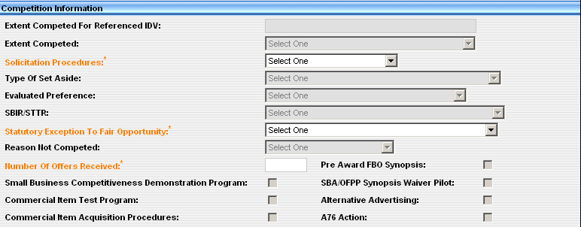
  - Extent Competed For Referenced IDV – This field is system populated from the referenced IDV.
  - Extent Competed - This is a code that represents the competitive nature of the contract
  - Solicitation Procedures - This is the designator for the solicitation procedures available. Report this code for the type of solicitation procedure used.
  - Type of Set Aside – This is the designator for type of set aside determined for the contract action.
  - Evaluated Preference -This is the designator for the type of preference determined for the contract action. Report a code from the drop down menu when a contract was made pursuant to the socio economic program price evaluation preferences.
  - SBIR/STTR:- This is the designator for the type of research determined for the contract action.
  - Statutory Exception to Fair Opportunity – This field is used to determine the extent of competition under a multiple award IDIQ contract in accordance with the Fair Opportunity Act. Report a code from the drop down menu when awarding a non-competitive task order or delivery order exceeding $2500.00 against an IDIQ contract
  - Reason Not Competed - This is the designator for solicitation procedures other than full and open competition pursuant to FAR 6.3 or other statutory basis. Enter the code that most appropriately defines the reason the action was not competed or not available for competition. For DOD, NASA, and the Coast Guard some types of actions may be competitive
  - Number of Offers Received – Enter the actual number of offers received for this award.
  - Small Business Competitiveness Demonstrations Program - FPDS-NG auto-populates this field when awards are made to U.S. business concerns (as a result of solicitations issued on or after Jan 1, 1989) for the designated industry groups or the ten targeted industry categories as defined by
  - Commercial Item Test Program – This field indicates the solicitation used Commercial Item Acquisition Procedures as defined by FAR Part 12 and Simplified Acquisition Procedures as defined by FAR Part 13.5 for acquisitions above the Simplified Acquisition threshold and below $5,000,000.
- Commercial Item Acquisition Procedures - This designates whether the solicitation used the special requirements for the acquisition of commercial items intended to more closely resemble those customarily used in the commercial marketplace as defined by FAR Part 12.
  - Pre Award FBO Synopsis – Select this field if the synopsis requirements of FAR Subpart 5.2 were followed.
  - SBA/OFPP Synopsis Waiver Pilot – Select this field if the agency is participating in the SBA/OFPP Pilot Program that allows for the SBA/OFPP Waiver Pilot Program. A waiver of the synopsis requirement in the FAR Subpart 5.2 applies when agencies acquire services with an anticipated value between $25,000 and $100,000 using small businesses set-asides. If the acquisition is subject to the Small Business Competitive Demonstration Test Program, then this code cannot be used.
  - Alternative Advertising – Select this if the contracting officer used methods in addition to or in place of those required by FAR 5.201 to advertise the requirement. Otherwise, leave blank.
A-76 (Fair Act) Action - Check the box if the contract action resulted from an A-76/Fair Act competitive sourcing process. Otherwise, leave this box blank.
- Preference Programs/Other Data section.
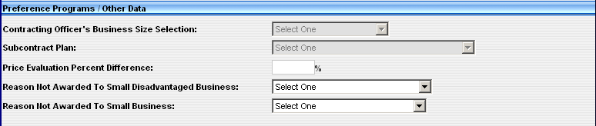
  - Contracting Officer’s Business Size Selection - This field indicates if the selected contractor meets the small business size standard for award to a small business based on the NAICS code.

  - Subcontract Plan - This field is used to provide subcontracting information to eSRS. Failure to complete this field accurately impacts other systems.

  - Price Evaluation Percent Difference - This is the percent difference between the award price and the lowest priced offer from a responsive, responsible non-HUBZone or non-SDB. Report this percent difference for HUBZone and SDB Price Evaluation Adjustment Programs. Report the percent difference between the award price and the lowest priced offer from a responsive, responsible non-SDB or non-HUBZone business. Calculate the percentage by dividing the difference (award price minus the lowest priced non-small or HUBZone business) by the lowest priced offer from a non-small business and enter it as a two-digit number rounded to the nearest percent. If no premium was paid, enter two zeros (00).
  - For example: 2% is input as 02, 12% is input as 12, and 5 1/2% is input as 06 (round to the nearest whole percent).

  - Reason Not Awarded to Small Disadvantaged Business – If the DUNS number or the CAGE code is for a business that is not a small disadvantaged business, enter the code that best explains why a small disadvantaged business was not selected.
  - Reason Not Awarded to Small Business – If the Contracting Officer’s Determination of Business Size is “Other Than Small Business,” enter the code that best explains why a small business was not selected.

Purchase Order
A Purchase Order is an offer by the government established to buy supplies or services under specified terms and conditions, using simplified acquisition procedures. This includes construction and research and development acquisitions.

Create a Purchase Order
- From the FPDS-NG Navigation screen, under the Awards section, select.
- FPDS-NG displays the Purchase Order (PO) screen ready for data entry.
- Transaction Information section.
  - Award Type – The award type defaults to Purchase Order.
  - Award Status – The award status defaults to New.
  - Prepared User – The Prepared By field defaults to the user ID of the person logged in to FPDS-NG.
  - Prepared Date – The Prepared Date field defaults to the current date.
  - Last Modified Date – The Last Modified By and Last Modified Date field are system generated when the document is updated and saved.
  - Last Modified User
- Document Information section
Award ID – Enter the Agency ID associated with the FIPS 95 code specified for the agency.
  - PIID No. – Enter the PIID Number (Contract, PO, or Agreement number) for the Standalone Contract.
Note: The PIID Number format must be uppercase, alphanumeric with no embedded spaces or special characters. FPDS-NG will convert lowercase letters to uppercase, remove leading or trailing blank spaces, and remove any non-alphanumeric characters prior to validation.
Note: The Contract Action type is a single character representing the Award Type. Refer to Section 2.8.1 for the PIID and contract action search functions.
Mod No. – Enter a modification number if the contract is being modified. The Mod No. field defaults to zero.
Trans No. – This field is required for DOD when completing multiple reports on a single contract.
Reference IDV ID – Enter the Reference PIID in the General Information section using the contract or agreement number of the IDV against which the order is placed.
Reason for Modification – Enter a reason for modification if this is a final contract that will be modified. The Reason for Modification dropdown menu is available when a modification number is changed from zero and the document is saved.
Solicitation ID – Enter the Solicitation ID used to link transactions in FPDS-NG to solicitation information. The Solicitation ID (Identifier) is taken from FedBizOpps. The number format must be uppercase, alphanumeric with no embedded spaces or special characters. This field holds a maximum of 25 characters. FPDS-NG will convert lowercase letters to uppercase, remove leading or trailing blank spaces, and remove any non-alphanumeric characters prior to validation.
- Date and Amounts section.
  - Date Signed – Enter the date the transaction was signed in the Date Signed field. This field represents the date a mutually binding agreement was reached. For a bilateral transaction, use the most recent date signed by the Contractor or the Contracting Officer. For a unilateral transaction, use the date on which the agreement was signed by the Contracting Officer.
  - Effective Date – Enter an effective date agreed to by the parties. The date that the parties agree to will be the starting date for the contract’s requirements. Usually, this is the same as the date signed. However, there are some cases where the date is not the signed date. For example, the effective date may be delayed to avoid major holidays or to coincide with the availability of funds; it may be predated to recognize that the contractor started work before the formal agreement was signed.
  - Completion Date – Enter the completion date for the mutually agreed upon time of completion for the contract including all options or other modifications.
  - Est. Ultimate Completion Date – Enter the mutually agreed upon contract completion date for the entire contract or order including all options or other modifications.
  - Action Obligation – Enter the net amount of funds (in dollars and cents) obligated or de-obligated by this transaction. If the net amount is zero, enter zero. If the net amount is a de-obligation, enter a minus sign in addition to the net amount.
  - Base and Exercised Options Value – Enter the total value (in dollars and cents) of the base contract plus any options that have been exercised at the time of award.
  - Base and All Options Value – Enter the mutually agreed upon total estimated contract or order value (in dollars and cents) including the base contract and any options.
Fees Paid For Use of IDV – List of administrative fees charged for using an IDV other than a Federal Supply Schedule (FSS). The fees can be one of the following:
1. Fixed
2. Range - Varies by amount
3. Range - Varies by Other Factors
- Purchaser Information section.
  - Contracting Office Agency ID – This field defaults from the user’s profile.
  - Contracting Office Agency Name – This field defaults from the user’s profile. This field identifies the agency name associated with the FIPS Pub. 95 code used for the contracting office agency ID.
  - Contracting Office ID – Enter the FIPS Pub. 95 code for the agency of the contracting office that executed or is otherwise responsible for the transaction. Contracting Office ID must be a valid contracting office code in the FPDS-NG Contracting Office/Funding Office Lookup Table for the agency. If the default code is not appropriate, enter the code for the contracting office that executed or is otherwise responsible for the transaction.
  - Contracting Office Name – FPDS-NG completes this field after the contracting office ID is entered. This field identifies the office name associated with the FIPS Pub. 95 code used for the Contracting Office ID.
  - Funding Agency ID – Enter the 4-6 character alphanumeric office code if applicable. Program/Funding Agency Code must be in the FPDS-NG FIPS 95 Agencies/Sub-agency Look-up table. If the default code is not appropriate, enter the code for the funding agency that executed or is otherwise responsible for the transaction.
  - Funding Agency Name – FPDS-NG completes this field after the Funding Agency ID is entered. This field identifies the funding agency name associated with the FIPS Pub. 95 codes.
  - Funding Office ID – Enter the 4-6 character alphanumeric office code if applicable. This field can be left blank or must be a valid funding office code selected from the FPDS-NG Government Office section. If Program/Funding Agency is DoD, then Program/Funding Office Code must have a value.
  - Funding Office Name – FPDS-NG completes this field after the Funding Office ID is entered. This field identifies the funding office name associated with the FIPS Pub. 95 codes.
  - Funded by Foreign Entity – If a foreign government or international organization bears some of the cost of the acquisition (this includes Foreign Military Sales), select this field. Otherwise, leave blank.
  - Reason for Inter-Agency Contracting – When the contracting agency or the funding agency is DoD and this procurement is for computer hardware or services, select a value for the reason certified by the funding office. Reason for purchase must be a valid value from the FPDS-NG Data Dictionary. If Program/Funding Agency - Code is DoD and Product or Service Code begins with ‘70,’ ‘D3,’ ‘H170,’ ‘H270,’ ‘H370,’ ‘H970,’ ‘J070,’ ‘K070,’ ‘L070,’ ‘N070,’ ‘U012,’ or ‘W070,’ then reason for purchase must not be blank.
- Contractor Information and Socio Economic Data section.
  - CCR Exceptions – If the vendor does not exist in CCR, use the CCR exception function to add the vendor. The vendor must have a valid DUNS number.
DUNS NUMBERS [R]
NOTE: You must have a DUNS number or you cannot complete a contract action report in FPDS-NG.
All vendor entries in FPDS-NG must have a DUNS number. There are two types of DUNS numbers, Individual or Vendor DUNS numbers, and Generic DUNS numbers.
- Individual or Vendor DUNS Numbers - The vendor obtains a DUNS through Dun and Bradstreet and enters it into CCR. Contracting officers may obtain DUNS numbers for a vendor but FPDS-NG requires the vendor to enter its information into CCR before a contract award is made.
  - Generic DUNS -There is a small subset of Generic DUNS registered with Dun and Bradstreet and CCR which you may use under the specific circumstances for that generic DUNS, such as “GPC (Government Purchase Card) Small Business”. This allows individuals to process Express reports. When you use a generic DUNS, FPDS-NG will populate the vendor name and address related to that generic DUNS.
  - Contractor Name from Contract – This field is system populated from the referenced IDV.
  - Socio Economic Data – When the vendor is selected, the socioeconomic data defaults to the information registered in CCR.
- Contract Data section.
  - Type of Contract – Select the Type of Contract pricing for this award.
  - Multi Year Contract – Select the checkbox when the definition for multiyear contract applies. Do not report contracts containing options as multiyear unless the definition below applies to the contract.
Note: A multiyear contract is a contract for the purchase of supplies or services for more than one, but not more than five program years. Such contracts are issued under specific congressional authority for specific programs.
Note: The key distinguishing difference between multiyear contracts and multiple year contracts is that multiyear contracts buy more than one year's requirement (of a product or service) without establishing and having to exercise an option for each program year after the first.
- Major Program – If your agency has designated Major Programs and this award is part of such a program, enter the code for the Major Program for this award.
- National Interest Action - This field identifies the awards made in response to national interest actions. The actions included in this list are determined by statute or executive order. Select the appropriate national emergency entry from the drop down menu for awards made for the direct assistance or support of victims
- Cost or Pricing Data - This is mandatory for DOD, and optional for civilian agencies. Select from the drop-down list the code that indicates whether cost or pricing data was obtained and certified, not obtained or waived. (DFAR 253.204-70(c)(4)(xi))
  - Purchase Card Used as Payment Method – If the method of payment under an Award is the Purchase Card select the checkbox.
  - Letter Contract - Check the box if the award is a Letter Contract. Otherwise, leave blank.
  - Performance Based Service Contract (PBSC) – Describes the requirements in terms of results required rather than the methods of performance of the work. Choose from the dropdown menu to indicate if this is a contract for services and 80% or more of the requirement is specified as a performance requirement, if this is a contract for services and less than 80% of the requirement is specified as a performance requirement, or if this is not applicable.
  - Contingency Humanitarian Peacekeeping Operation – If the award supports a contingency, humanitarian, or peacekeeping operation, then enter the appropriate code. The codes designate contract actions that exceed $200,000 and support a contingency operation, a humanitarian operation, or a peacekeeping operation. Otherwise, leave blank.
  - Contract Financing – Enter the code that best indicates whether or not progress payments, advance payments, or other financing methods were used. Contract Financing reflects the type of financing used to effect payment.
  - Cost Accounting Standards - This field is Mandatory for DOD, optional for civilian agencies. This field indicates whether the contract includes a Cost Accounting Standards clause. Check the box if the contract includes the Cost Accounting Standards clause. Otherwise, leave blank.

  - Number of Actions - Enter the number of actions. This is an optional field indicating the number input by the user identifying the number of actions that are reported in one transaction, when multiple actions are reported using Express Reporting. If left blank FPDS-NG defaults to the value of one.

  - Consolidated Contract - Select the box if the funding agency or contracting agency is DOD and the contract is for a consolidated requirement. Otherwise, leave blank. Do not check if Bundled Contract is selected
- Legislative Mandates and Principle Place of Performance section.
  - Clinger Cohen Act – Select this box if the transaction is subject to the Clinger Cohen Act, otherwise leave blank. Selecting this box tracks the acquisitions, use, and disposal of information technology by the Federal Government.
  - Service Contract Act – Select if the transaction is subject to the Service Contract Act, otherwise leave blank. Selecting this box tracks contracts, whose principal purpose is the furnishing of services in the U.S. through use of service employees.
  - Walsh Healy Act – Select if the transaction is subject to the Walsh Healy Act, otherwise leave blank. Selecting this box tracks contracts in excess of $10,000 for the manufacturing or furnishing of materials, supplies, articles, or equipment to the U.S. Government or the District of Columbia.
  - Davis Bacon Act – Select if the transaction is subject to the Davis Bacon Act, otherwise leave blank. Selecting this box tracks contracts in excess of $2,000 that deal with construction, renovations, and repairs of public buildings.
- Principal Place of Performance section.
  - Principal Place of Performance Code – The Principle Place of Performance indicates the location where the majority of work will be performed.
  - Principal Place of Performance Name – This is the name that corresponds with the code entered for the location where the majority of work will be performed.
  - Congressional District Place of Performance - FPDS-NG auto-populates this field based on the information provided in the Place of Performance Zip Code (+4) below.

  - Place of Performance Zip Code (+4) - Complete this field as it is required on all awards. FPDS-NG provides a link to the United States Postal Service website if you do not know the four digit extension to the place of performance zip code. You must complete this field in order for FPDS-NG to generate the Congressional District for the Place of Performance.
- Product or Service Information section.
  - Product or Service Code – Select the code that best identifies the product or service procured. If more than one code applies, then report the code that represents most of the ultimate contract value.
  - Principal NAICS Code – Select the code that was used in the solicitation.
  - System Equipment Code – This code applies to DoD Major Programs.
  - Country of Origin – Select the country where the product or service originated.
  - Place of Manufacture – Select the location where the item was manufactured from the dropdown menu.
  - Use of Recovered Material – Select this field to report the purchase of Environmental Protection Agency (EPA) designated products with a required minimum recovered material content as described in an agency’s Affirmative Procurement Program (APP).
  - InfoTech Commercial Item Category – Select a value certified by the funding office for the commercial nature of the products or services. This appears when the contracting agency or the funding agency is DoD and this procurement is for computer hardware or services.
  - Claimant Program Code – Select a claimant program number to designate a group of supplies, construction, or other services.
  - Sea Transportation – Select when the contractor's response to the provision at 252.247-7022, Representation of Extent of Transportation by Sea, or 252.212-7000(c)(2), Offer of Representations and Certifications - Commercial Items, indicates that the contractor anticipates that some of the supplies being provided may be transported by sea.
  - GFE/GFP Provided Under This Action – Select if the contract uses government furnished equipment/government furnished property, otherwise leave blank.
  - Use of EPA Designated Products – Select the Resource Conservation and Recovery Act (RCRA), when the purchase of Environmental Protection Agency (EPA) products is required.
  - Description of Requirement – Enter a brief description of the goods or services that are being purchased.
- Competition Information section.
  - Extent Competed For Referenced IDV – This field is system populated from the referenced IDV when the document is a DTO or BPA Call.
  - Extent Competed -. This is a code that represents the competitive nature of the contract
  - Solicitation Procedures -. This is the designator for the solicitation procedures available. Report this code for the type of solicitation procedure used
  - Type of Set Aside - This is the designator for type of set aside determined for the contract action.
  - Evaluated Preference -This is the designator for the type of preference determined for the contract action. Report a code from the drop down menu when a contract was made pursuant to the socio economic program price evaluation preferences.
  - Research - This is the designator for the type of research determined for the contract action.
  - Statutory Exception to Fair Opportunity -This field is used to determine the extent of competition under a multiple award IDIQ contract in accordance with the Fair Opportunity Act. Report a code from the drop down menu when awarding a non-competitive task order or delivery order exceeding $2500.00 against an IDIQ contract.
  - Reason Not Competed -This is the designator for solicitation procedures other than full and open competition pursuant to FAR 6.3 or other statutory basis. Enter the code that most appropriately defines the reason the action was not competed or not available for competition. For DOD, NASA, and the Coast Guard some types of actions may be competitive.
  - Number of Offers Received – Enter the actual number of offers received for this award.
  - Small Business Competitiveness Demonstrations Program - FPDS-NG auto-populates this field when awards are made to U.S. business concerns (as a result of solicitations issued on or after Jan 1, 1989) for the designated industry groups or the ten targeted industry categories as defined by
  - Commercial Item Test Program – Indicates the solicitation used Commercial Item Acquisition Procedures as defined by FAR Part 12 and Simplified Acquisition Procedures as defined by FAR Part 13.5 for acquisitions above the Simplified Acquisition threshold and below $5,000,000.
  - Commercial Item Acquisition Procedures – Report this code if the contract action is for a commercial item procured pursuant to the procedures in FAR Part 12 (Acquisition of Commercial Items) and clause 52.212-4 was included in the contract.
  - Pre Award FBO Synopsis – Select this field if the synopsis requirements of FAR Subpart 5.2 were followed.
  - SBA/OFPP Synopsis Waiver Pilot – Select this field if the agency is participating in the SBA/OFPP Pilot Program that allows for the SBA/OFPP Waiver Pilot Program. A waiver of the synopsis requirement in the FAR Subpart 5.2 applies when agencies acquire services with an anticipated value between $25,000 and $100,000 using small business set-asides. If the acquisition is subject to the Small Business Competitive Demonstration Test Program, then this code cannot be used.
  - Alternative Advertising – Select if the contracting officer used methods in addition to or in place of those required by FAR 5.201 to advertise the requirement. Otherwise, leave blank.
  - A-76 (Fair Act) Action - Check the box if the contract action resulted from an A-76/Fair Act competitive sourcing process. Otherwise, leave this box blank
- Preference Programs/Other Data section.
  - Contracting Officer Business Size Selection– Report the Contracting Officer’s determination of whether the selected contractor is considered a small business.
  - Subcontract Plan - This field is used to provide subcontracting information to eSRS. Failure to complete this field accurately impacts other systems.

  - Price Evaluation Percent Difference - This is the percent difference between the award price and the lowest priced offer from a responsive, responsible non-HUBZone or non-SDB. Report this percent difference for HUBZone and SDB Price Evaluation Adjustment Programs. Report the percent difference between the award price and the lowest priced offer from a responsive, responsible non-SDB or non-HUBZone business. Calculate the percentage by dividing the difference (award price minus the lowest priced non-small or HUBZone business) by the lowest priced offer from a non-small business and enter it as a two-digit number rounded to the nearest percent. If no premium was paid, enter two zeros (00).
  - For example: 2% is input as 02, 12% is input as 12, and 5 1/2% is input as 06 (round to the nearest whole percent).
  - Reason Not Awarded to Small Disadvantaged Business – If the DUNS number or the CAGE code is for a business that is not a small disadvantaged business, enter the code that best explains why a small disadvantaged business was not selected
  - Reason Not Awarded to Small Business – If the Contracting Officer’s Determination of Business Size is “Other Than Small Business,” enter the code that best explains why a small business was not selected.

Definitive Contract

A Standalone Contract is a mutually binding legal relationship obligating the seller to furnish the supplies or services (including construction) and the buyer to pay for them. It includes all types of commitments that obligate the government to an expenditure of appropriated funds and that, except as otherwise authorized, are in writing. In addition to bilateral instruments, contracts include (but are not limited to: awards and notices of awards; job orders or task letters issued under basic ordering agreements; letter contracts; orders, such as purchase orders, under which the contract becomes effective by written acceptance or performance; and bilateral contract modifications. Contracts do not include grants and cooperative agreements covered by 31 U.S.C. 6301, et seq. For discussion of various types of contracts, see Part 16.

Create a Standalone Contract
- From the FPDS-NG Navigation screen, under the Awards section, select.
- FPDS-NG displays the Standalone Contract screen ready for data entry.
- Enter data in the General Information section.
  - Award Type – The award type defaults to Standalone Contract.
  - Award Status – The award status defaults to New.
  - Prepared By – The Prepared By field defaults to the user ID of the person logged in to FPDS-NG.
  - Prepared Date – The Prepared Date field defaults to the current date.
  - Last Modified Date – The Last Modified By and Last Modified Date field are system generated when the document is updated and saved.
  - AGY – Enter the Agency ID associated with the FIPS 95 code specified for the agency.
  - PIID No. – Enter the PIID number (Contract, PO, or Agreement number) for the Standalone Contract.
Note: The PIID Number format must be uppercase, alphanumeric with no embedded spaces or special characters. FPDS-NG will convert lowercase letters to uppercase, remove leading or trailing blank spaces, and remove any non-alphanumeric characters prior to validation.
Note: The Contract Action type is a single character representing the Award Type. Refer to Section 2.8.1 for the PIID and contract action search functions.
  - Mod No. – Enter a modification number if the contract is being modified. The Mod No. field defaults to zero.
  - Reason for Modification – Enter a reason for modification if this is a final contract that will be modified. The Reason for Modification dropdown menu is available when a modification number is changed from zero and the document is saved.
  - Solicitation ID – Enter the Solicitation ID used to link transactions in FPDS-NG to solicitation information. The Solicitation ID (Identifier) is taken from FedBizOpps. The number format must be uppercase, alphanumeric with no embedded spaces or special characters. This field holds a maximum of 25 characters. FPDS-NG will convert lowercase letters to uppercase, remove leading or trailing blank spaces, and remove any non-alphanumeric characters prior to validation.
- Enter data in the Date and Amounts section.
  - Date Signed – Enter the date the transaction was signed in the Date Signed field. This field represents the date a mutually binding agreement was reached. For a bilateral transaction, use the most recent date signed by the Contractor or the Contracting Officer. For a unilateral transaction, use the date on which the agreement was signed by the Contracting Officer.
  - Effective Date – Enter an effective date agreed to by the parties. The date that the parties agree to will be the starting date for the contract’s requirements. Usually, this is the same as the date signed. However, there are some cases where the date is not the signed date. For example, the effective date may be delayed to avoid major holidays or to coincide with the availability of funds; it may be predated to recognize that the contractor started work before the formal agreement was signed.
  - Completion Date – Enter the completion date for the mutually agreed upon time of completion for the contract including all options or other modifications.
  - The Estimated Completion Date – Enter the mutually agreed upon contract completion date for the entire contract or order including all options or other modifications.
  - Action Obligation – Enter the net amount of funds (in dollars and cents) obligated or de-obligated by this transaction. If the net amount is zero, enter zero. If the net amount is a de-obligation, enter a minus sign in addition to the net amount.
  - Change in Base and Exercised Options Value – Enter the total value (in dollars and cents) of the base contract plus any options that have been exercised at the time of award.
  - Change in Base and All Options Value – Enter the mutually agreed upon total estimated contract or order value (in dollars and cents) including the base contract and any options.
- Enter data in the Purchaser Information section.
  - Contracting Office Agency ID – This field defaults from the user’s profile.
  - Contracting Office Agency Name – This field defaults from the user’s profile. This field identifies the agency name associated with the FIPS Pub. 95 code used for the contracting office agency ID.
  - Contracting Office ID – Enter the FIPS Pub. 95 code for the agency of the contracting office that executed or is otherwise responsible for the transaction. Contracting Office ID must be a valid contracting office code in the FPDS-NG Contracting Office/Funding Office Lookup Table for the agency. If the default code is not appropriate, enter the code for the contracting office that executed or is otherwise responsible for the transaction.
  - Contracting Office Name – FPDS-NG completes this field after the contracting office ID is entered. This field identifies the office name associated with the FIPS Pub. 95 code used for the Contracting Office ID.
  - Funding Agency ID – Enter the 4-6 character alphanumeric office code if applicable. Program/Funding Agency Code must be in the FPDS-NG FIPS 95 Agencies/Sub-agency Look-up table. If the default code is not appropriate, enter the code for the funding agency that executed or is otherwise responsible for the transaction.
  - Funding Agency Name – FPDS-NG completes this field after the Funding Agency ID is entered. This field identifies the funding agency name associated with the FIPS Pub. 95 codes.
  - Funding Office ID – Enter the 4-6 character alphanumeric office code if applicable. This field can be left blank or must be a valid funding office code selected from the FPDS-NG Government Office section. If Program/Funding Agency is DoD, then Program/Funding Office Code must have a value.
  - Funding Office Name – FPDS-NG completes this field after the Funding Office ID is entered. This field identifies the funding office name associated with the FIPS Pub. 95 codes.
  - Funded by Foreign Entity – If a foreign government or international organization bears some of the cost of the acquisition (this includes Foreign Military Sales), select this field. Otherwise leave blank.
  - Reason for Inter-Agency Contracting – When the contracting agency or the funding agency is DoD and this procurement is for computer hardware or services, select a value for the reason certified by the funding office. Reason for purchase must be a valid value from the FPDS-NG Data Dictionary. If Program/Funding Agency - Code is DoD and Product or Service Code begins with ‘70,’ ‘D3,’ ‘H170,’ ‘H270,’ ‘H370,’ ‘H970,’ ‘J070,’ ‘K070,’ ‘L070,’ ‘N070,’ ‘U012,’ or ‘W070,’ then reason for purchase must not be blank.
- Enter data in the Contractor Information and Socio Economic Data section.
  - CCR Exceptions – If the vendor does not exist in CCR, use the CCR exception function to add the vendor. The vendor must have a valid DUNS number.
  - Name – Enter the vendor's name
  - Socio Economic Data – When the vendor is selected, the socioeconomic data defaults to the information registered in CCR.
- Enter data in the Contract Data section.
  - Type of Contract – Select the Type of Contract pricing for this award.
  - Multi Year Contract – Select the checkbox when the definition for multiyear contract applies. Do not report contracts containing options as multiyear unless the definition below applies to the contract.
Note: A multiyear contract is a contract for the purchase of supplies or services for more than one, but not more than five program years. Such contracts are issued under specific congressional authority for specific programs.
Note: The key distinguishing difference between multiyear contracts and multiple year contracts is that multiyear contracts buy more than one year's requirement (of a product or service) without establishing and having to exercise an option for each program year after the first.
  - Major Program – If your agency has designated Major Programs and this award is part of such a program, enter the code for the Major Program for this award.
  - Cost or Pricing Data – Select the appropriate response from the drop down menu to indicate if cost or price comparison was or was not obtained.
  - Purchase Card Used as Payment Method – If the method of payment under an award is the Purchase Card select the checkbox.
  - Letter Contract – Select the checkbox if the award is a Letter Contract. A letter contract is a written preliminary contractual instrument that authorizes the contractor to begin immediately manufacturing supplies or performing services.
  - Performance Based Service Contract (PBSC) – Enter Y if this is a contract for services and 80% or more of the requirement is specified as a performance requirement. Enter N if this is a contract for services and less than 80% of the requirement is specified as a performance requirement. PBSC – Describes the requirements in terms of results required rather than the methods of performance of the work.
  - Contingency Humanitarian Peacekeeping Operation – If the award supports a contingency, humanitarian, or peacekeeping operation, then enter the appropriate code. The codes designate contract actions that exceed $200,000 and support a contingency operation, a humanitarian operation, or a peacekeeping operation. Otherwise, leave blank.
  - Contract Financing – Enter the code that best indicates whether or not progress payments, advance payments, or other financing methods were used. Contract Financing reflects the type of financing used to effect payment.
  - Cost Accounting Standards Clause – Select the checkbox if the contract includes a Cost Accounting Standards clause. Otherwise, leave blank.
- Enter data in the Legislative Mandates and Principle Place of Performance section.
  - Clinger Cohen Act – Select this box if the transaction is subject to the Clinger Cohen Act, otherwise leave blank. Selecting this box tracks the acquisitions, use, and disposal of information technology by the Federal Government.
  - Service Contract Act – Select if the transaction is subject to the Service Contract Act, otherwise leave blank. Selecting this box tracks contracts, whose principal purpose is the furnishing of services in the U.S. through use of service employees.
  - Walsh Healy Act – Select if the transaction is subject to the Walsh Healy Act, otherwise leave blank. Selecting this box tracks contracts in excess of $10,000 for the manufacturing or furnishing of materials, supplies, articles, or equipment to the U.S. Government or the District of Columbia.
  - Davis Bacon Act – Select if the transaction is subject to the Davis Bacon Act, otherwise leave blank. Selecting this box tracks contracts in excess of $2,000 that deal with construction, renovations, and repairs of public buildings.
- Enter data in the Principal Place of Performance section.
  - Principal Place of Performance Code – The Principle Place of Performance indicates the location where the majority of work will be performed.
  - Principal Place of Performance Name – This is the name that corresponds with the code entered for the location where the majority of work will be performed.
- Enter data in the Product or Service Information section.
  - Product or Service Code – Select the code that best identifies the product or service procured. If more than one code applies, then report the code that represents most of the ultimate contract value.
  - Principal NAICS Code – Select the code that was used in the solicitation.
  - Bundled Requirements – Select the code that best represents the agency’s reason for bundling contract requirements.
  - System Equipment Code – This code applies to DoD Major Programs.
  - Country of Origin – Select the country where the product or service originated.
  - Place of Manufacture – Select the location where the item was manufactured from the dropdown menu.
  - Use of Recovered Material – Select this field to report the purchase of Environmental Protection Agency (EPA) designated products with a required minimum recovered material content as described in an agency’s Affirmative Procurement Program (APP).
  - InfoTech Commercial Item Category – Select a value certified by the funding office for the commercial nature of the products or services. This appears when the contracting agency or the funding agency is DoD and this procurement is for computer hardware or services.
  - Claimant Program Code – Select a claimant program number to designate a group of supplies, construction, or other services.
  - Sea Transportation – Select this when the contractor's response to the provision at 252.247-7022, Representation of Extent of Transportation by Sea, or 252.212-7000(c)(2), Offer of Representations and Certifications - Commercial Items, indicates that the contractor anticipates that some of the supplies being provided may be transported by sea.
  - GFE/GFP Provided Under This Action – Select this if the contract uses Government Furbished Equipment/Government Furbished Property, otherwise leave blank.
  - Use of EPA Designated Products – Select the Resource Conservation and Recovery Act (RCRA), when the purchase of Environmental Protection Agency (EPA) products is required.
  - Description of Requirement – Enter a brief description of the goods or services that are being purchased.
- Enter data in the Competition Information section.
  - Extent Competed For Referenced IDV – This field is system populated from the referenced IDV when the document is a DTO or BPA Call.
  - Extent Competed - Click the drop-down and make a selection.
  - Solicitation Procedures - Click the drop-down and make a selection.
  - Type of Set Aside - Click the drop-down and make a selection.
  - Evaluated Preference - Click the drop-down and make a selection.
  - Research - Click the drop-down and make a selection.
  - Statutory Exception to Fair Opportunity - Click the drop-down and make a selection.
  - Reason Not Competed - Click the drop-down and make a selection.
  - Number of Offers Received – Enter the actual number of offers received for this award.
  - Commercial Item Test Program – Indicates the solicitation used Commercial Item Acquisition Procedures as defined by FAR Part 12 and Simplified Acquisition Procedures as defined by FAR Part 13.5 for acquisitions above the Simplified Acquisition threshold and below $5,000,000.
  - Commercial Item Acquisition Procedures – Report this code if the contract action is for a commercial item procured pursuant to the procedures in FAR Part 12 (Acquisition of Commercial Items) and clause 52.212-4 was included in the contract.
  - Pre Award FBO Synopsis – Select this field if the synopsis requirements of FAR Subpart 5.2 were followed.
  - SBA/OFPP Synopsis Waiver Pilot – Select this field if the agency is participating in the SBA/OFPP Pilot Program that allows for the SBA/OFPP Waiver Pilot Program. A waiver of the synopsis requirement in the FAR Subpart 5.2 applies when agencies acquire services with an anticipated value between $25,000 and $100,000 using small business set-asides. If the acquisition is subject to the Small Business Competitive Demonstration Test Program, then this code cannot be used.
  - Alternative Advertising – Select if the contracting officer used methods in addition to or in place of those required by FAR 5.201 to advertise the requirement. Otherwise, leave blank.
  - A76 Action – Select if the contract action resulted from an A-76/Fair Act competitive sourcing process, otherwise leave blank.
- Enter data in the Preference Programs/Other Data section.
  - Contracting Officer Business Size Determination – Report the Contracting Officer’s determination of whether the selected contractor is considered a small business.
  - Subcontract Plan – From the main menu select the code that reports whether or not a Subcontract Plan will be used for this award.
  - Price Evaluation Percent Difference – Report this percent difference for HUBZone and SDB Price Evaluation Adjustment Programs. Report the percent difference between the award price and the lowest price offer from a responsive, responsible non-Small Disadvantaged Business (SDB) or non-HUBZone business. Calculate the percentage by dividing the difference (award price minus the lowest price non-small or HUBZone business) by the lowest price offer from a non-small business and enter it as a two-digit number rounded to the nearest percent. If no premium was paid, enter two zeros (00).
  - Reason Not Awarded to Small Disadvantaged Business – If the DUNS number or the CAGE code is for a business that is not a small disadvantaged business, enter the code that best explains why a small disadvantaged business was not selected.
  - Reason Not Awarded to Small Business – If the Contracting Officer’s Determination of Business Size is “Other Than Small Business,” enter the code that best explains why a small business was not selected.

BPA Call
A BPA Call is an order against an existing blanket purchase agreement to request a service or product provided under the established agreement.

Create a BPA Call
- From the FPDS-NG Navigation screen, under the Awards section, select the link.
- FPDS-NG displays the BPA Call screen ready for data entry.
- Enter data in the General Information section.
  - Award Type – The award type defaults to BPA Call.
  - Award Status – The award status defaults to New.
  - Prepared By – The Prepared By field defaults to the user ID of the person logged in to FPDS-NG.
  - Prepared Date – The Prepared Date field defaults to the current date.
  - Last Modified Date – The Last Modified By and Last Modified Date field are system generated when the document is updated and saved.
  - AGY – Enter the Agency ID associated with the FIPS 95 code specified for the agency.
  - PIID No. – Enter the PIID number (Contract, PO, or Agreement number) for the Standalone Contract.
Note: The PIID Number format must be uppercase, alphanumeric with no embedded spaces or special characters. FPDS-NG will convert lowercase letters to uppercase, remove leading or trailing blank spaces, and remove any non-alphanumeric characters prior to validation.
Note: The Contract Action type is a single character representing the Award Type. Refer to Section 2.8.1 for the PIID and contract action search functions.
  - Mod No. – Enter a modification number if the contract is being modified. The Mod No. field defaults to zero.
  - Reference PIID – Enter the Reference PIID in the General Information section using the contract or agreement number of the IDV against which the order is placed. When reporting the initial load of a BPA under an FSS, report the FSS contract number.
Note: When reporting orders under IDVs (IDV) such as a GWAC, IDC, FSS, BOA, or BPA, report the Procurement Instrument Identifier (Contract Number or Agreement Number) of the IDV.
Note: BOAs and BPAs are with industries and not with other Federal Agencies. Refer to section 2.8.1 for the PIID and contract action search functions.
  - Reason for Modification – Enter a reason for modification if this is a final contract that will be modified. The Reason for Modification dropdown menu is available when a modification number is changed from zero and the document is saved.
  - Solicitation ID – Enter the Solicitation ID used to link transactions in FPDS-NG to solicitation information. The Solicitation ID (Identifier) is taken from FedBizOpps. The number format must be uppercase, alphanumeric with no embedded spaces or special characters. This field holds a maximum of 25 characters. FPDS-NG will convert lowercase letters to uppercase, remove leading or trailing blank spaces, and remove any non-alphanumeric characters prior to validation.
- Enter data in the Date and Amounts section.
  - Date Signed – Enter the date the transaction was signed in the Date Signed field. This field represents the date a mutually binding agreement was reached. For a bilateral transaction, use the most recent date signed by the Contractor or the Contracting Officer. For a unilateral transaction, use the date on which the agreement was signed by the Contracting Officer.
  - Effective Date – Enter an effective date agreed to by the parties. The date that the parties agree to will be the starting date for the contract’s requirements. Usually, this is the same as the date signed. However, there are some cases where the date is not the signed date. For example, the effective date may be delayed to avoid major holidays or to coincide with the availability of funds; it may be predated to recognize that the contractor started work before the formal agreement was signed.
  - Completion Date – Enter the completion date for the mutually agreed upon time of completion for the contract including all options or other modifications.
  - Action Obligation – Enter the net amount of funds (in dollars and cents) obligated or de-obligated by this transaction. If the net amount is zero, enter zero. If the net amount is a de-obligation, enter a minus sign in addition to the net amount.
  - Change in Base and Exercised Options Value – Enter the total value (in dollars and cents) of the base contract plus any options that have been exercised at the time of award.
  - Fees Paid For Use of IDV - List of administrative fees charged for using an IDV other than a Federal Supply Schedule (FSS) Vehicle. The fees can be one of the following:
1. Fixed
2. Range - Varies by amount
3. Range - Varies by Other Factors
- Enter data in the Purchaser Information section.
  - Contracting Office Agency ID – This field defaults from the user’s profile.
  - Contracting Office Agency Name – This field defaults from the user’s profile. This field identifies the agency name associated with the FIPS Pub. 95 code used for the contracting office agency ID.
  - Contracting Office ID – Enter the FIPS Pub. 95 code for the agency of the contracting office that executed or is otherwise responsible for the transaction. Contracting Office ID must be a valid contracting office code in the FPDS-NG Contracting Office/Funding Office Lookup Table for the agency. If the default code is not appropriate, enter the code for the contracting office that executed or is otherwise responsible for the transaction.
  - Contracting Office Name – FPDS-NG completes this field after the contracting office ID is entered. This field identifies the office name associated with the FIPS Pub. 95 code used for the Contracting Office ID.
  - Funding Agency ID – Enter the 4-6 character alphanumeric office code if applicable. Program/Funding Agency Code must be in the FPDS-NG FIPS 95 Agencies/Sub-agency Look-up table. If the default code is not appropriate, enter the code for the funding agency that executed or is otherwise responsible for the transaction.
  - Funding Agency Name – FPDS-NG completes this field after the Funding Agency ID is entered. This field identifies the funding agency name associated with the FIPS Pub. 95 codes.
  - Funding Office ID – Enter the 4-6 character alphanumeric office code if applicable. This field can be left blank or must be a valid funding office code selected from the FPDS-NG Government Office section. If Program/Funding Agency is DoD, then Program/Funding Office Code must have a value.
  - Funding Office Name – FPDS-NG completes this field after the Funding Office ID is entered. This field identifies the funding office name associated with the FIPS Pub. 95 codes.
  - Funded by Foreign Entity – If a foreign government or international organization bears some of the cost of the acquisition (this includes Foreign Military Sales), select this field. Otherwise, leave blank.
  - Reason for Inter-Agency Contracting – When the contracting agency or the funding agency is DoD and this procurement is for computer hardware or services, select a value for the reason certified by the funding office. Reason for purchase must be a valid value from the FPDS-NG Data Dictionary. If Program/Funding Agency - Code is DoD and Product or Service Code begins with ’70,’ ‘D3,’ ‘H170,’ ‘H270,’ ‘H370,’ ‘H970,’ ‘J070,’ ‘K070,’ ‘L070,’ ‘N070,’ ‘U012,’ or ‘W070,’ then reason for purchase must not be blank..
- Enter data in the Contractor Information and Socio Economic Data section.
  - CCR Exceptions – If the vendor does not exist in CCR use the CCR Exception function to add the vendor. The vendor must have a valid DUNS number.
  - Name – These fields are system populated from the Referenced IDV.
  - Socio Economic Data – These fields are system populated from the Referenced IDV.
- Enter data in the Contract Data section.
  - Purchase Card Used as Payment Method – If the method of payment under an Award is the Purchase Card select the checkbox.
- Enter data in the Product or Service Information section.
  - Product or Service Code – Select the code that best identifies the product or service procured. If more than one code applies, then report the code that represents most of the ultimate contract value.
  - Country of Origin – Select the country where the product or service originated.
  - Place of Manufacture – Select the location where the item was manufactured from the dropdown menu.
  - Sea Transportation – Select when the contractor's response to the provision at 252.247-7022, Representation of Extent of Transportation by Sea, or 252.212-7000(c)(2), Offer of Representations and Certifications - Commercial Items, indicates that the contractor anticipates that some of the supplies being provided may be transported by sea.
  - Description of Requirement – Enter a brief description of the goods or services that are being purchased.
- Enter data in the Competition Information section.
  - Extent Competed For Referenced IDV – This field is system populated from the referenced IDV.
  - Extent Competed - Click the drop-down and make a selection
  - Solicitation Procedures - Click the drop-down and make a selection.
  - Type of Set Aside - Click the drop-down and make a selection.
  - Evaluated Preference - Click the drop-down and make a selection.
  - Research - Click the drop-down and make a selection.
  - Statutory Exception to Fair Opportunity - Click the drop-down and make a selection.
  - Reason Not Competed - Click the drop-down and make a selection.
  - Number of Offers Received – Enter the actual number of offers received for this award.
  - Commercial Item Test Program – This field indicates the solicitation used Commercial Item Acquisition Procedures as defined by FAR Part 12 and Simplified Acquisition Procedures as defined by FAR Part 13.5 for acquisitions above the Simplified Acquisition threshold and below $5,000,000.
  - Pre Award FBO Synopsis – Select this field if the synopsis requirements of FAR Subpart 5.2 were followed.
  - SBA/OFPP Synopsis Waiver Pilot – Select this field if the agency is participating in the SBA/OFPP Pilot Program that allows for the SBA/OFPP Waiver Pilot Program. A waiver of the synopsis requirement in the FAR Subpart 5.2 applies when agencies acquire services with an anticipated value between $25,000 and $100,000 using small businesses set-asides. If the acquisition is subject to the Small Business Competitive Demonstration Test Program, then this code cannot be used.
  - Alternative Advertising – Select this if the contracting officer used methods in addition to or in place of those required by FAR 5.201 to advertise the requirement. Otherwise, leave blank.
- Enter data in the Preference Programs/Other Data section.
  - Reason Not Awarded to Small Disadvantaged Business – If the DUNS number or the CAGE code is for a business that is not a small disadvantaged business, enter the code that best explains why a small disadvantaged business was not selected.
  - Reason Not Awarded to Small Business – If the Contracting Officer’s Determination of Business Size is “Other Than Small Business,” enter the code that best explains why a small business was not selected.
.

Awards Inbox
The Awards Inbox provides you with information on the number and state of the awards which are currently assigned to your user ID. Five types of awards can be viewed in the Awards Inbox.
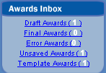
- Draft Awards
- Final Awards
- Error Awards
- Unsaved Awards
- Template Awards

Drafts Awards
Draft Awards are records which have been created in FPDS-NG, but that are missing certain required elements. These awards are saved for future completion in an ‘as-is’ state but are not subjected to the validation process.
Steps:
- Under the Awards Inbox, select the Draft Awards link to see all the awards with a Draft status.
- Select the document you want to open.

Final Awards
Final Awards are completed awards which have passed all validation rules.
Steps:
- Under the Awards Inbox, select the Final Awards link to see all the awards with a Final status.
- Select the document you want to open.

Error Awards
Error Awards are records which have been validated but contain errors which prevent the record from being approved. Error transactions are placed in the Error Inbox. The Error Inbox allows system administrators with the necessary privileges in FPDS-NG to correct individual and multiple transactions. FPDS-NG Agency System Administrators with the necessary privileges may correct final transactions.
To correct multiple transactions, the System Administrator will send the desired update to the FPDS-NG Administrator via the help desk. The FPDS-NG Administrator will make the desired changes and notify the System Administrator when the changes have been made.
Steps:
- Under the Awards Inbox, select the Error Awards link to see all the awards with errors.
- Select the document you want to open.

Unsaved Awards
Unsaved Awards are records which have been changed but not saved or validated prior to closing.
Steps:
- Under the Awards Inbox, select the Unsaved Awards link to see all the awards with an unsaved status.
- Select the document you want to open.

Template Awards
Template Awards are records that have been created to allow you to quickly complete additional records using the same basic contract information. Template Awards are useful for contracts in which you frequently place orders with a vendor.
Steps:
- Under the Awards Inbox, select the Template Awards link to see all of the award templates.
- Select the document you want to open.

Exercises: Awards

Create a Delivery/Task Order
- From the FPDS-NG Navigation screen, under the Awards section, select.
- FPDS-NG displays the Delivery/Task Order Contract screen ready for data entry.
- Enter data in theDocument Information section.
  - AGY – The agency ID is associated with the User ID and will default to “4740.” Use the lookup button and to create a new search. Enter “4740”in the Agency ID field and click and Select
  - PIID No. – Enter the PIID number “GSP0207CT1234” followed by your initials.
  - Reference IDV ID – Enter the reference PIID “GS23F0001M” and use the lookup button to select “4730” as the agency
- Enter data in the Date and Amounts section.
  - Date Signed – Enter the date the transaction was signed as “01/05/2006.”
  - Effective Date – Enter an effective date of “01/05/2006.”
  - Completion Date – Enter the completion date as “11/01/2006.”
  - The Estimated Ultimate Completion Date – Enter the estimated completion date as “12/01/2006.”
  - Action Obligation – Enter the amount “$25,000.00” in this field.
  - Base and Exercised Options Value – Enter the amount “$26,500.00” in this field.
  - Base and All Options Value – Enter the amount “$26,500.00” in this field.
- Enter data in the Purchaser Information section.
  - Contracting Office Agency ID – Enter “4740”
  - Contracting Office ID – select the lookup button, and enter “CT%`”
  - Select
  - Select
  - Funded by Foreign Entity – leave this field blank
6) The Contractor Information and Socio Economic Data section.
  - This section is system populated from the referenced IDV.
- Enter data in the Contract Data section.
  - Type of Contract – Select the type of contract as “Fixed Price” from the dropdown menu.
  - National Interest – Select “None” from the dropdown menu.
  - Performance Based Service Acquisition – Check the box for “This is a contract for services and less than 80% of the requirement is specified as performance requirement” from the dropdown menu.
- Enter data in the Legislative Mandates and Principle Place of Performance section.
  - Clinger Cohen Act – Select this box to indicate this transaction is subject to the Clinger Cohen Act.
- Enter data in the Principal Place of Performance section.
  - Principal Place of Performance Code – Using the lookup button, enter “VA” in the state code field and enter 22039 in the zipcode field and select. This will display your selections Select the radio button for “Fairfax Station” and click .
  - : Place of Performance Zip Code (+4) Click on the USPS link and enter the following information
  - 9860 Hampton Rd
  - Fairfax, Station, Va 22039”
  - Click submit
  - Close the window and enter 2809 for the 4+ zipcode.
- Enter data in the Product or Service Information section.
  - Product or Service Code –. Use the lookup button to make a selection. Enter R602 in the PSC Code field and select and select then select .
  - Bundled Contract – Select “Other” from the dropdown menu.
  - Place of Manufacture – From the dropdown menu select “ Mfg in the US”
  - GFE/GFP Provided Under This Action – leave this field blank.
  - Use of EPA Designated Products – Select “Not Required” from the dropdown menu.
  - Description of Requirement – Enter “Fire Control System.”
- Enter data in the Competition Information section.
  - Extent Competed – Select “Competitive Delivery Order” from the dropdown menu.
  - Solicitation Procedures – Select “No Solicitation Procedures Used “ from the dropdown menu.
  - Type of Set Aside – Select “No set aside used” from the dropdown menu.
  - Evaluated Preference – Select “No Preference used” from the dropdown menu.
- Enter data in the Preference Programs/Other Data section.
  - Reason Not Awarded to Small Disadvantaged Business – Select “SDB Not Solicited” from the dropdown menu.
- Select to save the document in draft status.
- Select to check for validation errors.
- Correct the errors listed at the top of the document in red. The following two errors should exist:
- When the "Change in Base and All Options Value" is less than $5M, the "Bundled Requirements" value must be "Not a Bundled Requirement.
  - Use the dropdown menu and select “Not a Bundled Requirement” to correct the validation error.
- The "Number of Offers Received" must be between 1 and 999.
  - Enter “3” in this field to correct the validation error.
- Select and then to check for validation errors.
- Select to finalize and save the document.
Note: After validating the document the fields containing error will be highlighted in red. The Validate button will not save any changes made to correct error(s) on the document. To save changes made to the document after validating select or.

Create a Purchase Order
- From the FPDS-NG Navigation screen, under the Awards section, select.
- FPDS-NG displays the PO screen ready for data entry.
- Enter data in the Document Information section.
  - AGY – The agency ID is associated with the User ID and will default to “4700.” Enter “4740”.
  - PIID No. – Enter the PIID number “GS00P07AAM” followed by your initials.
- Enter data in the Date and Amounts section.
  - Date Signed – Enter the date the transaction was signed as “01/05/2004.”
  - Effective Date – Enter an effective date of “01/05/2004.”
  - Completion Date – Enter the completion date as “05/01/2005.”
  - The Estimated Completion Date – Enter the estimated completion date as “05/01/2005.”
  - Action Obligation – Enter the amount “$6,000.00” in this field.
  - Base and Exercised Options Value – Enter the amount “$6,000.00” in this field.
  - Base and All Options Value – Enter the amount “$6,000.00” in this field.
- Enter data in the Purchaser Information section.
  - Contracting Office Agency ID – Enter 4740 and Select Click
  - Contracting Office ID – SelectEnter “AE000” in this field. Select and then Click.
  - Contracting Office Name – This field will be automatically populated.
  - Funding Agency ID – Skip this field; it will be system-populated in another step.
- Enter data in the Contractor Information and Socio Economic Data section.
  - Name –Select. From the vendor list Enter the vendor's name as “Chenega Advanced Solutions” click
  - Click. FPDS-NG will display your selection in the contractor fields.
  - Socio Economic Data – When the vendor is selected, the socioeconomic data defaults to the information registered in CCR.
- Enter data in the Contract Data section.
  - Type of Contract – Select “Fixed Price” from the dropdown menu for this award.
  - National Interest Action – Select “None” from the dropdown menu.
- Enter data in the Legislative Mandates and Principle Place of Performance section.
  - Davis Bacon. Act – Select this check box
- Enter data in the Principal Place of Performance section.
  - Principal Place of Performance Code – Select the lookup button, and enter “VA” in the state code field and “Richmond” in the Place Name field select . Select the VA location with a location code of 67000 and click . This will display your selection in the field.
  - Principal Place of Performance Name – This field is system-populated to correspond with the performance code entered.
  - Place of Performance Zip Code (+4) Click on the USPS link and enter the following information
  - Church Rd
  - Richmond, Va 23201”
  - Click submit
  - Close the window and enter 1808 for the 4+ zipcode.
- Enter data in the Product or Service Information section.
  - Product or Service Code – Select the lookup button and Enter “Z111” in this field.
  - Select
  - Click
  - Click
  - Principal NAICS Code – Enter “238%” in this field. Use the lookup button to select the description as “Painting and Wall Covering Contractors.” Select
  - Click
  - Country of Origin – Enter “US” in the first field and use the lookup button to select “United States” for the second field.
  - Click
  - Use of Recovered Material – Select “No Clauses Included” from the dropdown menu.
  - Use of EPA Designated Products – Select “Meets Requirements” from the dropdown menu.
  - Description of Requirement – Enter “Painting of Court House interior” in this field.
- Enter data in the Competition Information section.
  - Extent Competed – Select “Full and Open Competition” from the dropdown menu.
  - Solicitation Procedures – Select “Simplified Acquisition” from the dropdown menu.
  - Type of Set Aside – Select “No set aside” from the dropdown menu
  - Evaluated Preference – Select “No Preference used” from the dropdown menu.
  - Number of Offers Received – Enter “5” in this field.
- Enter data in the Preference Programs/Other Data section.
  - Contracting Officer Business Size Selection – Select “Small Business” from the dropdown menu.
- Select to save the document.
- Select
- If errors exist you will need to correct them before you can create a final document.
- Correct the error listed at the top of the document in red.
Correct the zipcode field by entering 23233
- Select to save the document.
- Select
- Select

Create a DefinitiveContract
- From the FPDS-NG Navigation screen, under the Awards section, select.
- FPDS-NG displays the Standalone Contract screen ready for data entry.
- Enter data in the Document Information section.
  - AGY – The agency ID is associated with the User ID Enter “4740.”
  - PIID No. – Enter “GS07P07CT” followed by your initials.
- Enter data in the Date and Amounts section.
  - Date Signed – Enter “04/01/2007” in this field.
  - Effective Date – Enter “04/01/2007” in this field.
  - Completion Date – Enter “12/01/2008” in this field.
  - The Estimated Completion Date – Enter “12/01/2010” in this field.
  - Action Obligation – Enter the amount “$650,000.00” in this field.
  - Base and Exercised Options Value – Enter the amount “$650,000.00” in this field.
  - Base and All Options Value – Enter the amount “$650,000.00” in this field.
- Enter data in the Purchaser Information section.
  - Contracting Office Agency ID – Defaults from the user profile Enter “4740”.
  - Contracting Office ID – Use the lookup button and Enter “CT000” in this field.
  - Click
  - Contracting Office Name – This field will be automatically populated.
- Enter data in the Contractor Information and Socio Economic Data section.
  - Name from Contract – Enter “MIDWEST RESEARCH INSTITUTE” and select. From the vendor list, selecton the left to make your selection for the Kansas City location.
  - Click on the right. FPDS-NG will display your selection in the contractor fields.
  - Socio Economic Data – When the vendor is selected, the socioeconomic data defaults to the information registered in CCR.
- Enter data in the Contract Data section.
  - Type of Contract – Select “Fixed Price Award Fee” from the dropdown menu.
  - National Interest Action – Select None from the dropdown menu.
  - Performance Based Service Acquisition– Select this check box.
- Enter data in the Legislative Mandates and Principle Place of Performance section.
- Service Contract Act – Check this box
- Enter data in the Principal Place of Performance section.
  - Principal Place of Performance Code –Select the Lookup button In the State Code field enter “VA” and enter Richmond in the Place Name field and select . and select for the first entry.
  - Principal Place of Performance Name – This field is system-populated to correspond with the performance code entered.
  - Principal Place of Performance Zip Code (+4) – Click the link and enter the following information:
  - State St
  - Richmond, VA 23201 and click Submit
  - Record the information 23231 – 1309 and close the window
  - Enter the correct zip code
- Enter data in the Product or Service Information section.
  - Product or Service Code – Enter “AN45” in this field. Use the lookup button to select the description as “HEALTH SERVICES (OPERATIONAL).” Click
  - Principal NAICS Code – Enter “525120” in this field. Use the lookup button to select the description as “HEALTH AND WELFARE FUNDS.” Click
  - Bundled Contract– Select “Not a bundled requirement” from the dropdown menu.
  - Country of Origin – Enter “US” and use the lookup button to select “United States.”
  - Use of Recovered Material – Select “No Clauses Included” from the dropdown menu.
  - Use of EPA Designated Products – Select “Not Required” from the dropdown menu.
  - Description of Requirement – Enter “Feasibility study for medical facility and location” in this field.
- Enter data in the Competition Information section.
  - Extent Competed – Select “Not Competed” from the dropdown menu.
  - Solicitation Procedures – Select “Basic Research “ from the dropdown menu.
  - Type of Set Aside – Select “No set aside used” from the dropdown menu.
  - Evaluated Preference – Select “No Preference used” from the dropdown menu.
  - Number of Offers Received – Enter “1” in this field.
- Enter data in the Preference Programs/Other Data section.
  - Contracting Officer Business Size Selection – Select “Other than Small Business” from the dropdown menu.
  - Subcontract Plan – Select “Plan Required Incentive not Included” from the dropdown menu.
- Select to save the document in draft status.
- Select to check for validation errors.
- Correct any errors listed at the top of the document in red.
Reason Not Competed – Select “Only one Source other” from the dropdown menu.
- Select .
- Select to check for validation errors

DO NOT approve the Definitive Contract document; this step will be performed in another exercise.

Create a BPA Call
- From the FPDS-NG Navigation screen, under the Awards section, select the link.
- FPDS-NG displays the BPA Call screen ready for data entry.
- Enter data in the Document Information section.
  - AGY – The agency ID is associated with the User ID Enter “4740.”
  - PIID No. – Enter “GSP0207DT000” followed by your initials.
  - Mod No. – The Mod No. field defaults to zero.
  - Reference IDV ID – Enter “GS02P06DT1BPA” in the PIID field and use the lookup button to select “4740” as the agency.
- Enter data in the Date and Amounts section.
  - Date Signed – Enter “04/26/2007” in this field.
  - Effective Date – Enter “04/26/2007” in this field.
  - Completion Date – Enter “04/25/2008” in this field.
  - Action Obligation – Enter “$325,000”
  - Base And Exercised Options Value – Enter “$325,000”
- Enter data in the Purchaser Information section.
  - Contracting Office Agency ID – Enter “4740” and use the lookup button to select
  - Click
  - Contracting Office ID – Enter “DT000” in this field.and select the lookup button, select
  - Contracting Office Name – this field will automatically be populated.
- Enter data in the Contractor Information and Socio Economic Data section.
  - This section is system populated from the referenced IDV.
- Enter data in the Contract Data section.
National Interest Action – Select “None” from the dropdown menu.
- Enter data in the Principal Place of Performance section
Principal Place of Performance Code – Select the lookup button and enter “NY” in the state code field and enter “Long Island City” in the Place Name field
Select
Select
  - Principal Place of Performance Name – This field is system-populated to correspond with the performance code entered.
  - Principal Place of Performance Zip Code (+4) – Click the link and enter the following information:
  - Main Ave.
  - Long Island City , NY 11101 and click Submit
  - Record the information 11101 – 4027 and close the window
  - Enter the correct zip code information
- Enter data in the Product or Service Information section.
  - Product or Service Code – Enter “7042” in this field. Using the lookup button, find the description “MINI & MICRO COMPUTER CONT DEVICES,”
  - Click
  - Country of Origin –Use the lookup button and Enter “GM” in the Country Short Code field.
  - Click
  - Click
  - Place of Manufacture – Select “Mfg. Outside the US Commercial Information Technology” from the dropdown menu.
  - Description of Requirement – Enter “Computer Cont. devices” in this field.
- Enter data in the Competition Information section.
  - Extent Competed – Select “Not Available for Competition” from the dropdown menu.
  - Solicitation Procedures – Select “Negotiated Proposal/Quote “ from the dropdown menu.
  - Type of Set Aside – Select “8(a) Sole Source” from the dropdown menu.
  - Evaluated Preference – Select “No Preference used” from the dropdown menu
  - Reason Not Competed – Select “Authorized by Statute” from the dropdown menu.
- Select to save the document in draft status.
- Select to check for validation errors.

Create a Template for an Award
This portion of the award exercises demonstrates using the award templates to reduce repetitive data entry. The Award Template created can be quickly accessed through the Award Inbox. The inbox is linked to the user’s ID and provides convenient access to contracts reported in the system by the user. Follow the steps below to create and retrieve a template.
    - Select from the main navigation screen. The PO form appears.
    - Scroll down to the Contractor Information section.
    - Contractor Name from Contract – Select beside the Name field. The Vendor selection screen is displayed. In the Name field at the bottom of the screen type in “OFFICE DEPOT%” and select . Choose the Office Depot Incorporated that has DUNS number 0716846660000 by selecting the radio button to the left of that choice.Select This populates the Contractor Information portion of the form.
    - Scroll down to the Product or Service Information section.
- NAICS Code –Select the lookup button and type “4%” in the NAICS Code field. Select . Choose “OFFICE EQUIPMENT MERCHANT WHOLESALERS” (423420) for the description and click .
- Description of Requirement – Type “OFFICE SUPPLIES” in this field.
    - At the top of the form, click. A screen will appear for saving the template that includes a name field and a description field for the template. Type “Class Test” for the template name and type “Office supplies for the branch offices” for the description field.
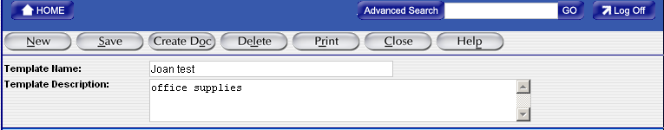
    - To save this information as a template for future use, select
    - After saving the template, select Home to return to the Navigation screen.
    - In the Awards Inbox on the main navigation screen, select the Template Awards inbox.
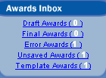
    - Select the link to your template by selecting the template name you created.
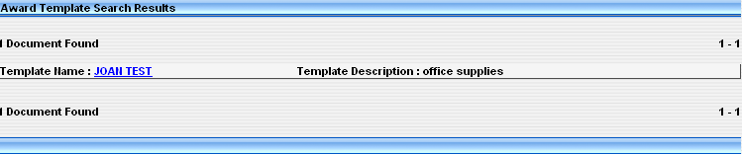
    - At the top of the screen, select “.” The form is now ready to have information added to it.

Finalize an Award
- Select the Draft Awards inbox from the main navigation screen. All of the awards in draft status will appear in a list format.
- Select the link for the draft Definitive Contract award that you created in the “Create a Definitive Contract” exercise.
- Select the button. The award is now in Final status.
- Select the Home button to return to the main navigation.
- Select the Final Awards inbox. The award you just approved is now located there.

Make a Correction to a Final Award
- Select the Final Awards inbox from the main navigation screen. All of the awards in final status will appear in a list format.
- Select the link for the final award that is a Definitive Contract.
- When the form appears, select from the top menu bar.
- Scroll down to the Contract Data.
- Type of Contract – From the dropdown menu, change this to “Cost No Fee.”
- Select . The award is now corrected.

Basic IDVs
The Basic IDVs (Indefinite Delivery Vehicles) function, shown in Figure 36, is used to add and modify IDVs. IDVs are divided into the following five different types:
- Federal Supply Schedule (FSS)
- Government Wide Acquisition Contract (GWAC)
- Basic Ordering Agreement (BOA)
- Blanket Purchase Agreement (BPA)
- Indefinite Delivery Contracts (IDC)
BASIC IDV COLUMN
An IDV is a basic award that allows you to place orders in accordance with the terms and conditions of the specific IDV.
A basic Indefinite Delivery Vehicle or Indefinite Quantity Vehicle is a contract/agreement awarded to one or more vendors to facilitate the delivery of supply and service orders. The only types of awards which may have orders placed against them are Federal Supply Schedule, GWAC, BOA, BPA, and IDC. The requirements of Part 17 of the FAR determine the type of IDV.
Use this column when entering the following type of document:
- FSS (Federal Supply Schedule) – GSA restricts creating this type of award to GSA and VA only.

- GWAC (Government Wide Acquisition Contract) – When creating a government wide vehicle for ordering IT services or supplies. OFPP grants the Delegation of authority to award these types of basic IDVs. This format is restricted for use by civilian agencies as DOD uses the basic IDC screen to report these actions. Examples of GWACs include but are not limited to COMMITS, ITOP, and SEWP.

- BOA (Basic Ordering Agreement) – A written instrument of understanding, negotiated between an agency, contracting activity, or contracting office, and a contractor, that contains: (1) terms and clauses applying to future actions (orders) between the parties during the term, (2) a description, as specific as practical, of supplies or services to be provided, and (3) methods for pricing, issuing, and delivering future orders under the BOA. A BOA is not a definitive contract. Only civilian agencies use this format to create the reporting document. DOD uses the IDC screen to report all IDV awards against which orders will be placed.

- BPA (Blanket Purchasing Agreement) – A vehicle against an FSS, in accordance with FAR Subpart 8.4. Ordering offices may establish BPAs against a Federal Supply Schedule. Only civilian agencies use this format to create the reporting document. DOD uses the IDC screen to report all IDV awards against which orders will be placed.

- IDC (Indefinite Delivery Contract) – A terms and condition vehicle against which you can write orders. The IDC type awards can be made to one or more vendors to facilitate the delivery of supply and/or service orders. These may include MAC (Multiple Award Contracts), IDIQ, IDDQ, and IDR. All DOD basic ordering vehicles shall use the IDC format. A FAR Part 13 BPA must use the IDC format because the BPA format cited above does not include all the fields necessary for an open market transaction.

Figure 36. Basic IDV Screen

FSS
A Federal Supply Schedule (FSS) is a GSA schedule contracting office issued publication containing the information necessary for placing delivery orders with schedule contractors. Ordering offices issue delivery orders directly to the schedule contractors for the required supplies and services.
The FSS program, directed and managed by the General Services Administration (GSA), provides Federal agencies with a simplified process for obtaining commonly used commercial supplies and services at prices associated with volume buying (also see 8.002). IDCs (including requirements contracts) are established with commercial firms to provide supplies and services at stated prices for given periods of time.

GWAC
A Government Wide Acquisition Contract (GWAC) is a task-order or delivery-order contract for information technology established by one agency for government-wide use. It is operated (1) by an executive agent designated by the Office of Management and Budget pursuant to section 5112(e) of the Clinger-Cohen Act, 40 U.S.C. 1412(e); or (2) under a delegation of procurement authority issued by the General Services Administration (GSA) prior to August 7, 1996, under authority granted GSA by the Brooks Act, 40 U.S.C. 759 (repealed by Pub. L. 104-106).
- From the FPDS-NG Navigation screen, under Basic IDVs, select.
- FPDS-NG displays the GWAC screen ready for data entry.
- Transaction Information section.
  - IDV Type – The IDV type defaults to Government Wide Acquisitions Contract.
  - IDV Status – The IDV status defaults to New.
  - Prepared User – The Prepared User field uses the user ID of the person logged in to FPDS-NG.
  - Prepared Date – The Prepared Date field defaults to the current date.
  - Last Modified User and Date – The Last Modified By and Last Modified Date field are system populated when the document is updated and saved.
- Document Information section
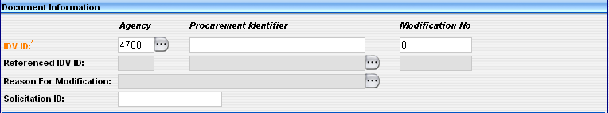
  - AGY – Enter the Agency ID associated with the FIPS 95 code specified for the agency.
  - PIID No. – Enter the PIID number (Contract, PO, or Agreement number) for the Standalone Contract.
Note: The PIID Number format must be uppercase, alphanumeric with no embedded spaces or special characters. FPDS-NG will convert lowercase letters to uppercase, remove leading or trailing blank spaces, and remove any non-alphanumeric characters prior to validation.
Note: The Contract Action type is a single character representing the Award type.
  - Mod No. – Enter a modification number if reporting modifications to contracts, agreements, or orders, report the modification number assigned by the reporting contracting office. For any given PIID, all Mod Nos. must be unique. The Mod No. field defaults to zero.
  - Referenced IDV - Enter the contract or agreement number of the IDV against which your order is placed. This field is mandatory for all delivery/task orders and BPA calls. FPDS-NG allows up to 50 characters. For definitive contract actions, this field should be blank.

  - Reason for Modification - When entering a modification you must select one from the drop down menu for modifying the contract or order:
  - Solicitation ID – Enter the Solicitation ID used to link transactions in FPDS-NG to solicitation information. The Solicitation ID (Identifier) is taken from FedBizOpps. Number format must be uppercase, alphanumeric with no embedded spaces or special characters. This field holds a maximum of 25 characters. FPDS-NG will convert lowercase letters to uppercase, remove leading or trailing blank spaces, and remove any non-alphanumeric characters prior to validation.
- Date and Amounts section.
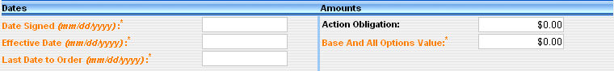
  - Date Signed – Enter the date the transaction was signed in the Date Signed field. This field represents the date a mutually binding agreement was reached. For a bilateral transaction, use the most recent date signed by the Contractor or the Contracting Officer. For a unilateral transaction, use the date on which the agreement was signed by the Contracting Officer.
  - Effective Date – Enter an effective date agreed to by the parties. The date that the parties agree to will be the starting date for the contract’s requirements. Usually this is the same as the date signed. However there are some cases where the date is not the signed date. For example, the effective date may be delayed to avoid major holidays or to coincide with the availability of funds; it may be predated to recognize that the contractor started work before the formal agreement was signed.
  - Last Date to Order – Enter the last date an order may be placed against this IDV.
  - Action Obligation – The amount that is obligated or de-obligated by this transaction. Enter the net amount of funds (in dollars and cents) obligated or de-obligated by this transaction. If the net amount is zero, enter zero. If the net amount is a de-obligation, enter a minus sign in addition to the net amount.
  - Base and All Options Value – Enter the total estimated value (in dollars and cents) for all orders that are expected to be placed against this contract.
- Purchaser Information section.
  - Contracting Office Agency ID – This field defaults from the user’s profile.
  - Contracting Office ID – Contracting Office ID must be a valid contracting office code in the FPDS-NG Contracting Office/Funding Office Lookup Table for the agency. If the default code is not appropriate, enter the code for the contracting office that executed or is otherwise responsible for the transaction.
Note: You can change the defaults by selecting to get the Selection screen.
  - Contracting Office Agency Name – This field defaults from the user’s profile. This field identifies the agency name associated with the FIPS Pub. 95 codes.
  - Contracting Office Name – This field defaults to the name associated with the Contracting Office ID.
- Contractor Information and Socio Economic Data section.
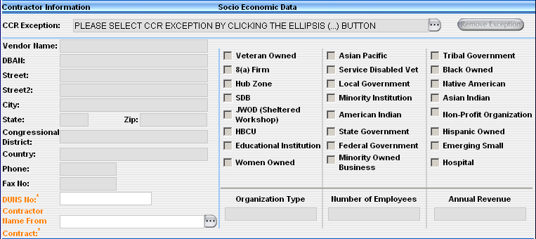
- CCR Exceptions – This field is used to enter a vendor that is not listed in CCR. If the vendor is not required to register with CCR use the lookup button to select the reason for the CCR exception. Enter the vendor information in the fields provided.
  - Socio Economic Data – When the vendor is selected, the socioeconomic data is automatically populated.
  - DUNS Numbers - All vendor entries in FPDS-NG must have a DUNS number. There are two types of DUNS numbers, Individual or Vendor DUNS numbers, and Generic DUNS numbers.
Individual or Vendor DUNS Numbers - The vendor obtains a DUNS from Dun and Bradstreet, and enters it into CCR.
Generic DUNS - There is a small subset of Generic DUNS registered with Dun and Bradstreet and CCR which you may use under the specific circumstances for that generic DUNS, such as “GPC (Government Purchase Card) Small Business”. This allows individuals to process Express reports. When you use a generic DUNS, FPDS-NG will populate the vendor name and address related to that generic DUNS, just like the vendor name and address is populated related to what is in CCR.

- Contractor Name from Contract- FPDS-NG requires the vendor name on all transactions. Click the lookup button to the right of the name field. The Vendor Selection search screen will appear. The best way to find the Vendor is to enter the DUNS number, or, if the DUNS number is not known, enter the Vendor Name. This information should match the information as shown in the CCR database. If it does not, verify that the correct DUNS number was chosen.
- Contract Data section.
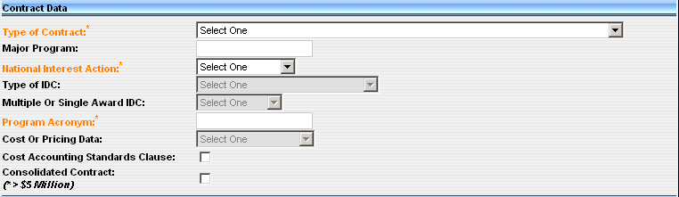
- Type of Contract – Select from the drop-down menu the type of contract from FAR Part16 that applies to this procurement. If award has more than one contract type, identify the type with greater contract value, or, for agencies that report multiple actions, follow agency instructions.
Note: A multiyear contract is a contract for the purchase of supplies or services for more than one, but not more than five program years. Such contracts are issued under specific congressional authority for specific programs.
Note: The key distinguishing difference between multiyear contracts and multiple year contracts is that multiyear contracts buy more than one year's requirement (of a product or service) without establishing and having to exercise an option for each program year after the first.
- Major Program - This field is not required but you may enter it. This is the agency determined code for a major program within the agency. For an Indefinite Delivery Vehicle, this may be the name of a GWAC (such as, ITOPS or COMMITS).
- National Interest Action - This field identifies the awards made in response to national interest actions
- Type of IDC - This field identifies whether the IDC or Multi-Agency Contract is Indefinite Delivery/Requirements, Indefinite Delivery/Indefinite Quantity, or Indefinite Delivery/Definite Quantity (FAR 16.5).
- Multiple or Single Award IDC - This field indicates whether the contract is one of many that resulted from a single solicitation, or all of the contracts are for the same or similar items, and contracting officers are required to compare their requirements with the offerings under more than one contract or are required to acquire the requirement competitively among the awardees.
- Program Acronym – This is the short name or title used for a GWAC or other contracting program. Examples include COMMITS, ITOPS, and SEWP.
- Cost Accounting Standards Clause – Mandatory for DOD. Select the checkbox if the contract includes a Cost Accounting Standards clause. Otherwise, leave blank.
- Consolidated Contract - Check the box if the Funding Agency or Contracting Agency is DOD, and the contract is for a consolidated requirement. Otherwise, leave blank.
- Legislative Mandates and Inter Agency IDV Authority section.
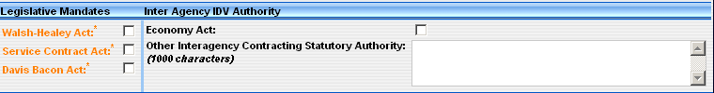
- Walsh Healy Act – Select if the transaction is subject to the Walsh Healy Act, otherwise leave blank. Selecting this box tracks contracts in excess of $10,000 for the manufacturing or furnishing of materials, supplies, articles, or equipment to the U.S. government or the District of Columbia.
- Service Contract Act – Select if the transaction is subject to the Service Contract Act, otherwise leave blank. Selecting this box tracks contracts, whose principal purpose is the furnishing of services in the U.S. through use of service employees.
- Davis Bacon Act – Select if the transaction is subject to Davis Bacon Act, otherwise leave blank. Selecting this box tracks contracts in excess of 2,000 that deal with construction, renovations, and repairs of public buildings.
- Economy Act – Select for the initial load of a Multi-Agency Contract or other IDC if the award is authorized pursuant to the Economy Act, otherwise leave blank.
- Other Statutory Authority – For the initial load of a Multi-Agency Contract or other IDC, enter the citation for the law, if the award is authorized pursuant to legislation other than the Economy Act.
- Contract Marketing Data section.
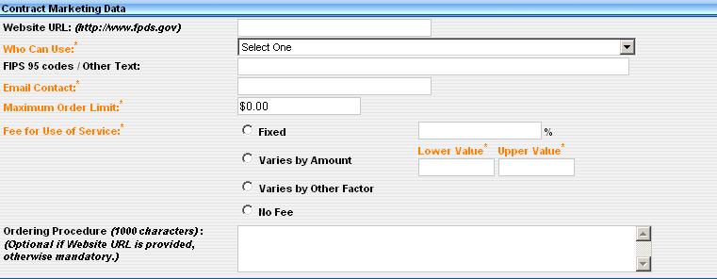
- Website URL – The Web site URL is used for interagency IDVs. Enter the Web site URL where users may go to get more information on the contract or program.
- Who can use – This field is designed for agencies that place orders against this IDV. For the initial award of an IDV, select the appropriate choice from the dropdown menu. Certain code words require a list of agencies that may order from the IDV.
- FIPS 95 Codes/Other Text – Enter information here only the Agencies with the FIPS 95 codes listed in a comma-separated format.
- Email Contact – Enter an email address as a point of contact for users that are placing orders against the IDV.
- Maximum Order Limit – This field specifies the maximum dollar amount that can be applied to a single order against the IDV.
- Fee For Use of Service – List of administrative fees charged for using an IDV other than a Federal Supply Schedule (FSS) Vehicle. The fees can be one of the following:
1. Fixed
2. Range - Varies by amount
3. Range - Varies by Other Factors.
4. No Fee
- Ordering Procedure – For the initial IDV, describe ordering procedures, unless included in the government Web site listed in the “Web Site URL” data element (5A)..
- Product or Service Information section.
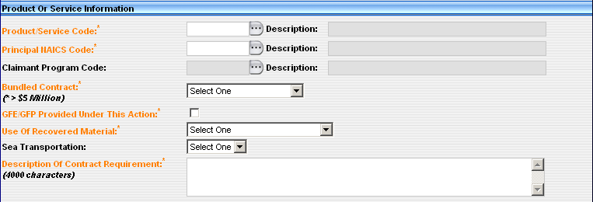
- Product or Service Code – Select the code that best identifies the product or service procured. If more than one code applies, then report the code that represents most of the ultimate contract value.
- Principal NAICS Code – Report the code that was used in the solicitation.
- Claimant Program Code - A claimant program number designates a grouping of supplies, construction, or other services
- Bundled Contract – This designates when the value of the contract, including all options, is expected to exceed $5M. In addition, the contracting officer determines if this contract action is a result of consolidating two or more requirements previously solicited, provided, or performed by small businesses under separate contracts into a solicitation unsuitable for small business. (FAR 19.2, FAR 4.6, FAR 2.101). For DOD, bundling is a subset of consolidated contract
- GFE/GFP Provided Under This Action – Select if the contract uses government furnished equipment/government furnished property, otherwise leave blank.
- Use of Recovered Material –This designates whether the contracting officer included clauses in the contract for the Recovered Material Certification and/or Estimate of Percentage of Recovered Material Content for EPA designated Products.
- Sea Transportation – Select when the contractor's response to the provision at 252.247-7022, Representation of Extent of Transportation by Sea, or 252.212-7000(c)(2), Offer of Representations and Certifications - Commercial Items, indicates that the contractor anticipates that some of the supplies being provided may be transported by sea.
- Description of Contract Requirement – Enter a brief description of the goods or services that are being purchased or for an IDV, a brief description of the goods or services available.
- Competition Information section.
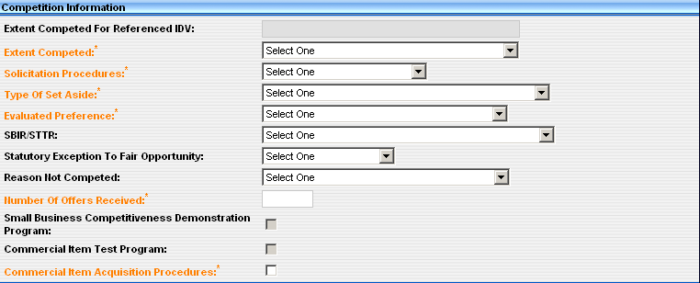
- Extent Competed For Referenced IDV – This field is not available for direct data entry. This field is linked to the Extent Competed field. When an IDV is referenced on a DTO or BPA Call the Extent Competed information populates the Extent Competed For Referenced IDV field.
- Extent Competed - This is a code that represents the competitive nature of the contract.
- Solicitation Procedures - This is the designator for the solicitation procedures available. Report this code for the type of solicitation procedure used..
- Type of Set Aside - This is the designator for type of set aside determined for the contract action..
- Evaluated Preference - This is the designator for the type of preference determined for the contract action. Report a code from the drop down menu when a contract was made pursuant to the socio economic program price evaluation preferences, see FAR 19.11 and FAR 19.13.
- Research - This is the designator for the type of research determined for the contract action.
- Statutory Exception to Fair Opportunity -This field is used to determine the extent of competition under a multiple award IDIQ contract in accordance with the Fair Opportunity Act. Report a code from the drop down menu when awarding a non-competitive task order or delivery order exceeding $2500.00 against an IDIQ contract.
- Reason Not Competed -This is the designator for solicitation procedures other than full and open competition pursuant to FAR 6.3 or other statutory basis. Enter the code that most appropriately defines the reason the action was not competed.
- Number of Offers Received – Enter the actual number of offers received.
- Small Business Competitiveness Demonstration Program - FPDS-NG auto-populates this field when awards are made to U.S. business concerns (as a result of solicitations issued on or after Jan 1, 1989) for the designated industry groups or the ten targeted industry categories as defined by FAR 19.10.
- Commercial Item Test Program – This designates whether the solicitation used Commercial Item Acquisition Procedures as defined by FAR Part 12 and Simplified Acquisition Procedures as defined by FAR Part 13.5 for acquisitions above the Simplified Acquisition Threshold and below $5,000,000.
- Commercial Item Acquisition Procedures – Report this code if the contract action is for a commercial item procured pursuant to the procedures in FAR Part 12 (Acquisition of Commercial Items) and clause 52.212-4 was included in the contract.
- Preference Programs/Other Data section.
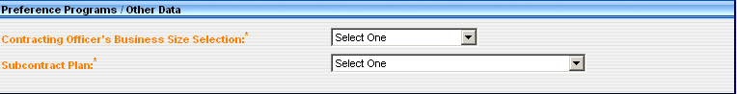
- Contracting Officer Business Size Selection– Report the Contracting Officer’s determination of whether the selected contractor is a small business for this contract.
- Subcontract Plan – Report the code for the subcontracting requirement (see FAR Part 19.702).

BOA
A Basic Ordering Agreement (BOA) is a written instrument of understanding, negotiated between an agency, contracting activity, or contracting office and a contractor, that contains (1) terms and clauses applying to future contracts (orders) between the parties during its term, (2) a description, as specific as practicable, of supplies or services to be provided, and (3) methods for pricing, issuing, and delivering future orders under the BOA. A BOA is not a contract.
A BOA may be used to expedite contracting for uncertain requirements for supplies or services when specific items, quantities, and prices are not known at the time the agreement is executed, but a substantial number of requirements for the type of supplies or services covered by the agreement are anticipated to be purchased from the contractor. Under proper circumstances, the use of these procedures can result in economies in ordering parts for equipment support by reducing administrative lead-time, inventory investment, and inventory obsolescence due to design changes.

Create a BOA
- From the FPDS-NG Navigation screen, under Basic IDVs, select thelink
- FPDS-NG displays the BOA screen ready for data entry.
- Document Information section.
  - IDV Type – The IDV type defaults to Basic Ordering Agreement.
  - IDV Status – The IDV status defaults to New.
  - Prepared User– The Prepared User field uses the user ID of the person logged in to FPDS-NG.
  - Prepared Date – The Prepared Date field defaults to the current date.
  - Last Modified User and Date – The Last Modified By and Last Modified Date field are system populated when the document is updated and saved.
  - AGY – Enter the Agency ID associated with the FIPS 95 code specified for the agency.
  - PIID No. – Enter the PIID number (Contract, PO, or Agreement number) for the Standalone Contract.
Note: The PIID Number format must be uppercase, alphanumeric with no embedded spaces or special characters. FPDS-NG will convert lowercase letters to uppercase, remove leading or trailing blank spaces, and remove any non-alphanumeric characters prior to validation.
Note: The Contract Action type is a single character representing the Award Type.
  - Mod No. – Enter a modification number if reporting modifications to contracts, agreements, or orders, report the modification number assigned by the reporting contracting office. For any given PIID, all Mod Nos. must be unique. The Mod No. field defaults to zero.
  - Solicitation ID – Enter the Solicitation ID used to link transactions in FPDS-NG to solicitation information. The Solicitation ID (Identifier) is taken from FedBizOpps. Number format must be uppercase, alphanumeric with no embedded spaces or special characters. This field holds a maximum of 25 characters. FPDS-NG will convert lowercase letters to uppercase, remove leading or trailing blank spaces, and remove any non-alphanumeric characters prior to validation.
- Date and Amounts section.
  - Date Signed – Enter the date the transaction was signed in the Date Signed field. This field represents the date a mutually binding agreement was reached. For a bilateral transaction, use the most recent date signed by the Contractor or the Contracting Officer. For a unilateral transaction, use the date on which the agreement was signed by the Contracting Officer.
  - Effective Date – Enter an effective date agreed to by the parties. The date that the parties agree to will be the starting date for the contract’s requirements. Usually this is the same as the date signed. However there are some cases where the date is not the signed date. For example, the effective date may be delayed to avoid major holidays or to coincide with the availability of funds; it may be predated to recognize that the contractor started work before the formal agreement was signed.
  - Last Date to Order – Enter the last date an order may be placed against this IDV.
  - Action Obligation – The amount that is obligated or de-obligated by this transaction. Enter the net amount of funds (in dollars and cents) obligated or de-obligated by this transaction. If the net amount is zero, enter zero. If the net amount is a de-obligation, enter a minus sign in addition to the net amount.
  - Base and All Options Value – Enter the total estimated value (in dollars and cents) for all orders that are expected to be placed against this contract.
- Purchaser Information section.
  - Contracting Office Agency ID – This field defaults from the user’s profile.
  - Contracting Office ID – Contracting Office ID must be a valid contracting office code in the FPDS-NG Contracting Office/Funding Office Lookup Table for the agency. If the default code is not appropriate, enter the code for the contracting office that executed or is otherwise responsible for the transaction.
Note: You can change the defaults by selecting the Lookup button to get the Selection screen.
  - Contracting Office Agency Name – This field defaults from the user’s profile. This field identifies the agency name associated with the FIPS Pub. 95 codes.
  - Contracting Office Name – This field defaults to the name associated with the Contracting Office ID.
- Contractor Information and Socio Economic Data section.
- CCR Exceptions – This field is used to enter a vendor that is not listed in CCR. If the vendor is not required to register with CCR use the lookup button to select the reason for the CCR exception. Enter the vendor information in the fields provided.
  - Name – Enter the vendor's make your selection.
  - Socio Economic Data – When the vendor is selected, the socioeconomic data is automatically populated.
- Contract Data section.
- Type of Contract – Select the contract type from the dropdown menu.
Note: A multiyear contract is a contract for the purchase of supplies or services for more than one, but not more than five program years. Such contracts are issued under specific congressional authority for specific programs.
Note: The key distinguishing difference between multiyear contracts and multiple year contracts is that multiyear contracts buy more than one year's requirement (of a product or service) without establishing and having to exercise an option for each program year after the first.
- Program Acronym – This is the short name or title used for a GWAC or other contracting program. Examples include COMMITS, ITOPS, and SEWP.
- Cost Accounting Standards Clause – Select the checkbox if the contract includes a Cost Accounting Standards clause. Otherwise, leave blank.
- Enter data in the Legislative Mandates and Inter Agency IDV Authority section.
- Walsh Healy Act – Select if the transaction is subject to the Walsh Healy Act, otherwise leave blank. Selecting this box tracks contracts in excess of $10,000 for the manufacturing or furnishing of materials, supplies, articles, or equipment to the U.S. government or the District of Columbia.
- Service Contract Act – Select if the transaction is subject to the Service Contract Act, otherwise leave blank. Selecting this box tracks contracts, whose principal purpose is the furnishing of services in the U.S. through use of service employees.
- Davis Bacon Act – Select if the transaction is subject to Davis Bacon Act, otherwise leave blank. Selecting this box tracks contracts in excess of 2,000 that deal with construction, renovations, and repairs of public buildings.
- Economy Act – Select for the initial load of a Multi-Agency Contract or other IDC if the award is authorized pursuant to the Economy Act, otherwise leave blank.
- Other Statutory Authority – For the initial load of a Multi-Agency Contract or other IDC, enter the citation for the law, if the award is authorized pursuant to legislation other than the Economy Act.
- Contract Marketing Data section.
- Website URL – The Web site URL is used for interagency IDVs. Enter the Web site URL where users may go to get more information on the contract or program.
- Who can use – This field is designed for agencies that place orders against this IDV. For the initial award of an IDV, select the appropriate choice from the dropdown menu. Certain code words require a list of agencies that may order from the IDV.
- FIPS 95 Codes/Other Text – Enter information here only the Agencies with the FIPS 95 codes listed in a comma-separated format.
- Email Contact – Enter an email address as a point of contact for users that are placing orders against the IDV.
- Maximum Order Limit – This field specifies the maximum dollar amount that can be applied to a single order against the IDV.
- Fee For Use of Service – List of administrative fees charged for using an IDV other than a Federal Supply Schedule (FSS) Vehicle. The fees can be one of the following:
1. Fixed
2. Range - Varies by amount
3. Range - Varies by Other Factors.
- Ordering Procedure – For the initial IDV, describe ordering procedures, unless included in the government Web site listed in the “Web Site URL” data element (5A). This field is optional if the Web Site URL (Data Element 5A) is provided, otherwise it is mandatory.
- Product or Service Information section.
- Product or Service Code – Select the code that best identifies the product or service procured. If more than one code applies, then report the code that represents most of the ultimate contract value.
- Principal NAICS Code – Report the code that was used in the solicitation.
- Bundled Requirements – Select the code that best represents the agency’s reason for bundling contract requirements.
- GFE/GFP Provided Under This Action – Select if the contract uses government furnished equipment/government furnished property, otherwise leave blank.
- Use of Recovered Material – When EPA-Designated Product(s) is coded A, B, C, or D, use one of the following codes. Otherwise, leave Recovered Material Clauses blank.
- Sea Transportation – Select when the contractor's response to the provision at 252.247-7022, Representation of Extent of Transportation by Sea, or 252.212-7000(c)(2), Offer of Representations and Certifications - Commercial Items, indicates that the contractor anticipates that some of the supplies being provided may be transported by sea.
- Description of Contract Requirement – Enter a brief description of the goods or services that are being purchased or for an IDV, a brief description of the goods or services available
- Competition Information section.
- Extent Competed For Referenced IDV – This field is not available for direct data entry. This field is linked to the Extent Competed field. When an IDV is referenced on a DTO or BPA Call the Extent Competed information populates the Extent Competed For Referenced IDV field.
- Extent Competed For Referenced IDV – This field is not available for direct data entry. This field is linked to the Extent Competed field. When an IDV is referenced on a DTO or BPA Call the Extent Competed information populates the Extent Competed For Referenced IDV field.
- Extent Competed - This is a code that represents the competitive nature of the contract.
- Solicitation Procedures - This is the designator for the solicitation procedures available. Report this code for the type of solicitation procedure used..
- Type of Set Aside - This is the designator for type of set aside determined for the contract action..
- Evaluated Preference - This is the designator for the type of preference determined for the contract action. Report a code from the drop down menu when a contract was made pursuant to the socio economic program price evaluation preferences, see FAR 19.11 and FAR 19.13.
- Research - This is the designator for the type of research determined for the contract action.
- Statutory Exception to Fair Opportunity -This field is used to determine the extent of competition under a multiple award IDIQ contract in accordance with the Fair Opportunity Act. Report a code from the drop down menu when awarding a non-competitive task order or delivery order exceeding $2500.00 against an IDIQ contract.
- Reason Not Competed -This is the designator for solicitation procedures other than full and open competition pursuant to FAR 6.3 or other statutory basis. Enter the code that most appropriately defines the reason the action was not competed.
- Number of Offers Received – Enter the actual number of offers received.
- Small Business Competitiveness Demonstration Program - FPDS-NG auto-populates this field when awards are made to U.S. business concerns (as a result of solicitations issued on or after Jan 1, 1989) for the designated industry groups or the ten targeted industry categories as defined by FAR 19.10.
- Commercial Item Test Program – This designates whether the solicitation used Commercial Item Acquisition Procedures as defined by FAR Part 12 and Simplified Acquisition Procedures as defined by FAR Part 13.5 for acquisitions above the Simplified Acquisition Threshold and below $5,000,000.
- Commercial Item Acquisition Procedures – Report this code if the contract action is for a commercial item procured pursuant to the procedures in FAR Part 12 (Acquisition of Commercial Items) and clause 52.212-4 was included in the contract.

- Preference Programs/Other Data section.
- Contracting Officer Business Size Selection– Report the Contracting Officer’s determination of whether the selected contractor is a small business for this contract.
- Subcontract Plan – Report the code for the subcontracting requirement (see FAR Part 19.702).

BPA

A Blanket Purchase Agreement (BPA) is a simplified method of filling anticipated repetitive needs for services and products. BPAs are "charge accounts" that ordering offices establish with GSA Schedule contractors to provide themselves with an easy ordering tool. In accordance with Federal Acquisition Regulation (FAR) 8.404, ordering offices may establish BPAs under any GSA Schedule contract. There are certain benefits and advantages of establishing a BPA with a GSA FSS contractor.
Generally, a single BPA should be established when you can easily define your services and/or products requirements and a firm-fixed price or ceiling price can be established. Since a best value selection is made when the single BPA is established, you do not need to make a separate best value selection for each order under the BPA.
Multiple BPAs should be established when you cannot easily define your services and/or products requirements, or you determine that more than one BPA is needed to meet your needs. First determine which GSA Schedule contractors are technically qualified and then establish BPAs with them. When multiple BPAs are established, each order must be competed among all BPA holders and a best value selection must be made each time an order is placed.

Create a BPA
- From the FPDS-NG Navigation screen, under Basic IDVs, select.
- FPDS-NG displays the BPA screen ready for data entry.
- Enter data in the General Information section.
  - IDV Type – The IDV type defaults to Blanket Purchase Agreement.
  - IDV Status – The IDV status defaults to New.
  - Prepared By – The Prepared By field uses the user ID of the person logged in to FPDS-NG.
  - Prepared Date – The Prepared Date field defaults to the current date.
  - Last Modified By and Date – The Last Modified By and Last Modified Date field are system populated when the document is updated and saved.
  - AGY – Enter the Agency ID associated with the FIPS 95 code specified for the agency.
  - PIID No. – Enter the PIID number (Contract, PO, or Agreement number) for the Standalone Contract.
Note: The PIID Number format must be uppercase, alphanumeric with no embedded spaces or special characters. FPDS-NG will convert lowercase letters to uppercase, remove leading or trailing blank spaces, and remove any non-alphanumeric characters prior to validation.
Note: The Contract Action type is a single character representing the Award Type.
  - Mod No. – Enter a modification number if reporting modifications to contracts, agreements, or orders, report the modification number assigned by the reporting contracting office. For any given PIID, all Mod Nos. must be unique. The Mod No. field defaults to zero.
  - Solicitation ID – Enter the Solicitation ID used to link transactions in FPDS-NG to solicitation information. The Solicitation ID (Identifier) is taken from FedBizOpps. Number format must be uppercase, alphanumeric with no embedded spaces or special characters. This field holds a maximum of 25 characters. FPDS-NG will convert lowercase letters to uppercase, remove leading or trailing blank spaces, and remove any non-alphanumeric characters prior to validation.
- Enter data in the Date and Amounts section.
  - Date Signed – Enter the date the transaction was signed in the Date Signed field. This field represents the date a mutually binding agreement was reached. For a bilateral transaction, use the most recent date signed by the Contractor or the Contracting Officer. For a unilateral transaction, use the date on which the agreement was signed by the Contracting Officer.
  - Effective Date – Enter an effective date agreed to by the parties. The date that the parties agree to will be the starting date for the contract’s requirements. Usually this is the same as the date signed. However there are some cases where the date is not the signed date. For example, the effective date may be delayed to avoid major holidays or to coincide with the availability of funds; it may be predated to recognize that the contractor started work before the formal agreement was signed.
  - Last Date to Order – Enter the last date an order may be placed against this IDV.
  - Action Obligation – The amount that is obligated or de-obligated by this transaction. Enter the net amount of funds (in dollars and cents) obligated or de-obligated by this transaction. If the net amount is zero, enter zero. If the net amount is a de-obligation, enter a minus sign in addition to the net amount.
  - Change in Base and All Options Value – Enter the total estimated value (in dollars and cents) for all orders that are expected to be placed against this contract.
- Enter data in the Purchaser Information section.
  - Contracting Office Agency ID – This field defaults from the user’s profile.
  - Contracting Office ID – Contracting Office ID must be a valid contracting office code in the FPDS-NG Contracting Office/Funding Office Lookup Table for the agency. If the default code is not appropriate, enter the code for the contracting office that executed or is otherwise responsible for the transaction.
Note: You can change the defaults by selecting Lookup button to get the Selection screen.
  - Contracting Office Agency Name – This field defaults from the user’s profile. This field identifies the agency name associated with the FIPS Pub. 95 codes.
  - Contracting Office Name – This field defaults to the name associated with the Contracting Office ID.
- Enter data in the Contractor Information and Socio Economic Data section.
- CCR Exceptions – This field is used to enter a vendor that is not listed in CCR. If the vendor is not required to register with CCR use the lookup button to select the reason for the CCR exception. Enter the vendor information in the fields provided.
  - Name – Enter the vendor's name
  - Socio Economic Data – When the vendor is selected, the socioeconomic data is automatically populated.
- Enter data in the Contract Data section.
- Type of Contract – Select the contract type from the dropdown menu.
- Major Program – If your agency has designated Major Programs and this award is part of such a program, enter the code for the major program for this award.
Note: A multiyear contract is a contract for the purchase of supplies or services for more than one, but not more than five program years. Such contracts are issued under specific congressional authority for specific programs.
Note: The key distinguishing difference between multiyear contracts and multiple year contracts is that multiyear contracts buy more than one year's requirement (of a product or service) without establishing and having to exercise an option for each program year after the first.
- Program Acronym – This is the short name or title used for a GWAC or other contracting program. Examples include COMMITS, ITOPS, and SEWP.
- Cost Accounting Standards Clause – Select the checkbox if the contract includes a Cost Accounting Standards clause. Otherwise, leave blank.
- Enter data in the Legislative Mandates and Inter Agency IDV Authority section.
- Walsh Healy Act – Select if the transaction is subject to the Walsh Healy Act, otherwise leave blank. Selecting this box tracks contracts in excess of $10,000 for the manufacturing or furnishing of materials, supplies, articles, or equipment to the U.S. government or the District of Columbia.
- Service Contract Act – Select if the transaction is subject to the Service Contract Act, otherwise leave blank. Selecting this box tracks contracts, whose principal purpose is the furnishing of services in the U.S. through use of service employees.
- Davis Bacon Act – Select if the transaction is subject to Davis Bacon Act, otherwise leave blank. Selecting this box tracks contracts in excess of 2,000 that deal with construction, renovations, and repairs of public buildings.
- Economy Act – Select for the initial load of a Multi-Agency Contract or other IDC if the award is authorized pursuant to the Economy Act, otherwise leave blank.
- Other Statutory Authority – For the initial load of a Multi-Agency Contract or other IDC, enter the citation for the law, if the award is authorized pursuant to legislation other than the Economy Act.
- Enter data in the Contract Marketing Data section.
- Website URL – The Web site URL is used for interagency IDVs. Enter the Web site URL where users may go to get more information on the contract or program.
- Who can use – This field is designed for agencies that place orders against this IDV. For the initial award of an IDV, select the appropriate choice from the dropdown menu. Certain code words require a list of agencies that may order from the IDV.
- FIPS 95 Codes/Other Text – Enter information here only the Agencies with the FIPS 95 codes listed in a comma-separated format.
- Email Contact – Enter an email address as a point of contact for users that are placing orders against the IDV.
- Maximum Order Limit – This field specifies the maximum dollar amount that can be applied to a single order against the IDV.
- Fee For Use of Service – List of administrative fees charged for using an IDV other than a Federal Supply Schedule (FSS) Vehicle. The fees can be one of the following:
1. Fixed
2. Range - Varies by amount
3. Range - Varies by Other Factors.
- Ordering Procedure – For the initial IDV, describe ordering procedures, unless included in the government Web site listed in the “Web Site URL” data element (5A). This field is optional if the Web Site URL (Data Element 5A) is provided, otherwise it is mandatory.
- Enter data in the Product or Service Information section.
- Product or Service Code - Select the code that best identifies the product or service procured. If more than one code applies, then report the code that represents most of the ultimate contract value.
- Principal NAICS Code - Report the code that was used in the solicitation.
- Bundled Requirements - Select the code that best represents the agency’s reason for bundling contract requirements.
- GFE-GFP Provided Under This Action - Select if the contract uses GFE or GFP, otherwise leave blank.
- Use of Recovered Material - When EPA-Designated Product(s) is coded A, B, C, or D, use one of the following codes. Otherwise, leave Recovered Material Clauses blank.
- Sea Transportation - Select when the contractor's response to the provision at 252.247-7022, Representation of Extent of Transportation by Sea, or 252.212-7000(c)(2), Offer or Representations and Certifications - Commercial Items, indicates that the contractor anticipates that some of the supplies being provided may be transported by sea.
- Description of Contract Requirement - Enter a brief description of the goods or services that are being purchased or for an IDV, a brief description of the goods or services available.
- Enter data in the Competition Info section.
- Extent Competed For Referenced IDV – This field is not available for direct data entry. This field is linked to the Extent Competed field. When an IDV is referenced on a DTO or BPA Call the Extent Competed information populates the Extent Competed For Referenced IDV field.
- Extent Competed - Click the drop-down and make a selection.
- Solicitation Procedures - Click the drop-down and make a selection.
- Type of Set Aside - Click the drop-down and make a selection.
- Evaluated Preference - Click the drop-down and make a selection.
- Research - Click the drop-down and make a selection.
- Statutory Exception to Fair Opportunity - Click the drop-down and make a selection.
- Reason Not Competed - Click the drop-down and make a selection.
- Commercial Item Test Program – Designates whether the solicitation used Commercial Item Acquisition Procedures as defined by FAR Part 12 and Simplified Acquisition Procedures as defined by FAR Part 13.5 for acquisitions above the Simplified Acquisition Threshold and below $5,000,000
- Enter data in the Preference Programs/Other Data section.
- Contracting Officer Business Size Determination – Report the Contracting Officer’s determination of whether the selected contractor is a small business for this contract.
- Subcontract Plan – Report the code for the subcontracting requirement (see FAR Part 19.702).

IDC
An Indefinite Delivery Contract (IDC) is a vehicle that has been awarded to one or more vendors to facilitate the delivery of supply and service orders. An IDV is established by an award from the FSS, GWAC, BOA, etc. The determination of the type of IDV is defined by the requirements of the FAR.
There are three types of IDCs:
- A Definite Quantity Contract provides for delivery of a definite quantity of supplies or services for a fixed period, with deliveries to be scheduled at designated locations upon order.
- A Requirements Contract provides for filling all purchase requirements of designated government activities for supplies or services during a specified contract period, with deliveries to be scheduled by placing orders with the contractor.
- An Indefinite Quantity Contract provides for an indefinite quantity, within stated limits, of specific supplies or services to be furnished during a fixed period with deliveries to be scheduled by placing orders with the contractor. The contract shall require the government to order and the contractor to furnish at least a stated minimum quantity of supplies or services and, if ordered, the contractor to furnish any additional quantities not to exceed a stated maximum. Indefinite Quantity Contracts are sometimes referred to as Task Order and Delivery Order Contracts.
  - A Task Order Contract is a contract for services that does not specify a firm quantity of services (other than a minimum or maximum quantity) and that provides for issuance of orders for the performance of tasks during the period of the contract.
  - A Delivery Order Contract is a contract for supplies that does not specify a firm quantity of supplies (other than a minimum or maximum quantity) and that provides for the issuance of orders for the delivery of supplies during the period of the contract.

Create an IDC
- From the FPDS-NG Navigation screen, under Basic IDVs, select.
- FPDS-NG displays the IDC screen ready for data entry.
- Enter data in the General Information section.
  - IDV Type – The IDV type defaults to Indefinite Delivery Contract.
  - IDV Status – The IDV status defaults to New.
  - Prepared By – The Prepared By field uses the user ID of the person logged in to FPDS-NG.
  - Prepared Date – The Prepared Date field defaults to the current date.
  - Last Modified By and Date – The Last Modified By and Last Modified Date field are system populated when the document is updated and saved.
  - AGY – Enter the Agency ID associated with the FIPS 95 code specified for the agency.
  - PIID No. – Enter the PIID number (Contract, PO, or Agreement number) for the Standalone Contract.
Note: The PIID Number format must be uppercase, alphanumeric with no embedded spaces or special characters. FPDS-NG will convert lowercase letters to uppercase, remove leading or trailing blank spaces, and remove any non-alphanumeric characters prior to validation.
Note: The Contract Action type is a single character representing the Award Type.
  - Mod No. – Enter a modification number if reporting modifications to contracts, agreements, or orders, report the modification number assigned by the reporting contracting office. For any given PIID, all modifications numbers must be unique. The Mod No. field defaults to zero.
  - Solicitation ID – Enter the Solicitation ID used to link transactions in FPDS-NG to solicitation information. The Solicitation ID (Identifier) is taken from FedBizOpps. Number format must be uppercase, alphanumeric with no embedded spaces or special characters. This field holds a maximum of 25 characters. FPDS-NG will convert lowercase letters to uppercase, remove leading or trailing blank spaces, and remove any non-alphanumeric characters prior to validation.
- Enter data in the Date and Amounts section.
  - Date Signed – Enter the date the transaction was signed in the Date Signed field. This field represents the date a mutually binding agreement was reached. For a bilateral transaction, use the most recent date signed by the Contractor or the Contracting Officer. For a unilateral transaction, use the date on which the agreement was signed by the Contracting Officer.
  - Effective Date – Enter an effective date agreed to by the parties. The date that the parties agree to will be the starting date for the contract’s requirements. Usually this is the same as the date signed. However there are some cases where the date is not the signed date. For example, the effective date may be delayed to avoid major holidays or to coincide with the availability of funds; it may be predated to recognize that the contractor started work before the formal agreement was signed.
  - Last Date to Order – Enter the last date an order may be placed against this IDV.
  - Action Obligation – The amount that is obligated or de-obligated by this transaction. Enter the net amount of funds (in dollars and cents) obligated or de-obligated by this transaction. If the net amount is zero, enter zero. If the net amount is a de-obligation, enter a minus sign in addition to the net amount.
  - Change in Base and All Options Value – Enter the total estimated value (in dollars and cents) for all orders that are expected to be placed against this contract.
- Enter data in the Purchaser Information section.
  - Contracting Office Agency ID – This field defaults from the user’s profile.
  - Contracting Office ID – Contracting Office ID must be a valid contracting office code in the FPDS-NG Contracting Office/Funding Office Lookup Table for the agency. If the default code is not appropriate, enter the code for the contracting office that executed or is otherwise responsible for the transaction.
Note: You can change the defaults by selectingto get the Selection Screen.
  - Contracting Office Agency Name – This field defaults from the user’s profile. This field identifies the agency name associated with the FIPS Pub. 95 codes.
  - Contracting Office Name – This field defaults to the name associated with the Contracting Office ID.
- Enter data in the Contractor Information and Socio Economic Data section.
- CCR Exceptions – This field is used to enter a vendor that is not listed in CCR. If the vendor is not required to register with CCR use the lookup button to select the reason for the CCR exception. Enter the vendor information in the fields provided.
  - Name – Enter the vendor's nane
  - Socio Economic Data – When the vendor is selected, the socioeconomic data is automatically populated.
- Enter data in the Contract Data section.
- Type of Contract – Select the contract type from the dropdown menu.
- Major Program – If your agency has designated Major Programs and this award is part of such a program, enter the code for the major program for this award.
Note: A multiyear contract is a contract for the purchase of supplies or services for more than one, but not more than five program years. Such contracts are issued under specific congressional authority for specific programs.
Note: The key distinguishing difference between multiyear contracts and multiple year contracts is that multiyear contracts buy more than one year's requirement (of a product or service) without establishing and having to exercise an option for each program year after the first.
- Type of IDC – Select the type of IDC from the dropdown menu.
- Multiple or Single Award IDC – Select either multiple or single award from the dropdown menu.
- Program Acronym – The short name or title used for a GWAC or other contracting program. Examples include COMMITS, ITOPS, and SEWP.
- Cost or Pricing Data - Select the appropriate response (No, Not Obtained – Waived, or Yes) from the dropdown menu.
- Cost Accounting Standards Clause – Select the checkbox if the contract includes a Cost Accounting Standards clause. Otherwise, leave blank.
- Enter data in the Legislative Mandates and Inter Agency IDV Authority section.
- Walsh Healy Act – Select if the transaction is subject to the Walsh Healy Act, otherwise leave blank. Selecting this box tracks contracts in excess of $10,000 for the manufacturing or furnishing of materials, supplies, articles, or equipment to the U.S. government or the District of Columbia.
- Service Contract Act – Select if the transaction is subject to the Service Contract Act, otherwise leave blank. Selecting this box tracks contracts, whose principal purpose is the furnishing of services in the U.S. through use of service employees.
- Davis Bacon Act – Select if the transaction is subject to Davis Bacon Act, otherwise leave blank. Selecting this box tracks contracts in excess of 2,000 that deal with construction, renovations, and repairs of public buildings.
- Economy Act – Select for the initial load of a Multi-Agency Contract or other IDC if the award is authorized pursuant to the Economy Act, otherwise leave blank.
- Other Statutory Authority – For the initial load of a Multi-Agency Contract or other IDC, enter the citation for the law, if the award is authorized pursuant to legislation other than the Economy Act.
- Enter data in the Contract Marketing Data section.
- Website URL – The Web site URL is used for interagency IDVs. Enter the Web site URL where users may go to get more information on the contract or program.
- Who can use – This field is designed for agencies that place orders against this IDV. For the initial award of an IDV, select the appropriate choice from the dropdown menu. Certain code words require a list of agencies that may order from the IDV.
- FIPS 95 Codes/Other Text – Enter information here only the Agencies with the FIPS 95 codes listed in a comma-separated format.
- Email Contact – Enter an email address as a point of contact for users that are placing orders against the IDV.
- Maximum Order Limit – This field specifies the maximum dollar amount that can be applied to a single order against the IDV.
- Fee For Use of Service – List of administrative fees charged for using an IDV other than a Federal Supply Schedule (FSS) Vehicle. The fees can be one of the following:
1. Fixed
2. Range - Varies by amount
3. Range - Varies by Other Factors.
- Ordering Procedure – For the initial IDV, describe ordering procedures, unless included in the government Web site listed in the “Web Site URL” data element (5A). This field is optional if the Web site URL (Data Element 5A) is provided, otherwise it is mandatory.
- Enter data in the Product or Service Information section.
- Product or Service Code – Select the code that best identifies the product or service procured. If more than one code applies, then report the code that represents most of the ultimate contract value.
- Principal NAICS Code – Report the code that was used in the solicitation.
- Claimant Program Code – Enter the appropriate code from the DoD Procurement Coding Manual Section III, DoD Claimant Program Number.
- Bundled Requirements – Select the code that best represents the agency’s reason for bundling contract requirements.
- GFE/GFP Provided Under This Action – Select if the contract uses government furnished equipment/government furnished property, otherwise leave blank.
- Use of Recovered Material – When EPA-Designated Product(s) is coded A, B, C, or D, use one of the following codes. Otherwise, leave Recovered Material Clauses blank.
- Sea Transportation – Select when the contractor's response to the provision at 252.247-7022, Representation of Extent of Transportation by Sea, or 252.212-7000(c)(2), Offer of Representations and Certifications - Commercial Items, indicates that the contractor anticipates that some of the supplies being provided may be transported by sea.
- Description of Contract Requirement – Enter a brief description of the goods or services that are being purchased or for an IDV, a brief description of the goods or services available.
- Enter data in the Competition Info section.
- Extent Competed For Referenced IDV – This field is not available for direct data entry. This field is linked to the Extent Competed field. When an IDV is referenced on a DTO or BPA Call the Extent Competed information populates the Extent Competed For Referenced IDV field.
- Extent Competed - Click the drop-down and make a selection.
- Solicitation Procedures - Click the drop-down and make a selection.
- Type of Set Aside - Click the drop-down and make a selection.
- Evaluated Preference - Click the drop-down and make a selection.
- Research - Click the drop-down and make a selection.
- Statutory Exception to Fair Opportunity - Click the drop-down and make a selection.
- Reason Not Competed - Click the drop-down and make a selection.
- Number of Offers Received – Enter the actual number of offers received.
- Commercial Item Test Program – Designates whether the solicitation used Commercial Item Acquisition Procedures as defined by FAR Part 12 and Simplified Acquisition Procedures as defined by FAR Part 13.5 for acquisitions above the Simplified Acquisition Threshold and below $5,000,000.
- Enter data in the Preference Programs/Other Data section.
- Contracting Officer Business Size Determination – Report the Contracting Officer’s determination of whether the selected contractor is a small business for this contract.
- Subcontract Plan – Report the code for the subcontracting requirement (see FAR Part 19.702).

IDV Inbox
The IDV Inbox provides you with information on the number and state of the IDVs which are currently assigned to your user ID. Five types of IDVs can be viewed in the IDVs Inbox.
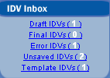
- Draft IDVs
- Final IDVs
- Error IDVs
- Unsaved IDVs
- Template IDVs

Draft IDVs
Draft IDVs are records which have been created in FPDS-NG, but that are missing certain required elements. These IDVs are saved for future completion in an ‘as-is’ state but are not subjected to the validation process.
Steps:
- Under the IDV Inbox, select the Draft IDVs link to see all the IDVs with a Draft status.
- Select the document you want to open.

Final IDVs
Final IDVs are completed records which have been successfully passed validation rules and have been saved.
Steps:
- Under the IDV Inbox, select the Final IDVs link to see all the IDVs with a Final status.
- Select the document you want to open.

Error IDVs
Error IDVs are records which have been validated but contain errors which prevent the record from being approved. Error transactions are placed in the Error Inbox. The Error Inbox allows system administrators with the necessary privileges in FPDS-NG to correct individual and multiple transactions. FPDS-NG Agency System Administrators with the necessary privileges may correct final transactions.
To correct multiple transactions, the System Administrator will send the desired update to the FPDS-NG Administrator via the help desk. The FPDS-NG Administrator will make the desired changes and notify the System Administrator when the changes have been made.
Steps:
- Under the IDV Inbox, select the Error IDVs to see all the IDVs with errors.
- Select the document you want to open.

Unsaved IDVs
Unsaved IDVs are records which have been changed but not saved or validated prior to closing.
Steps:
- Under the IDV Inbox, select the Unsaved IDVs link to see all the IDVs with an unsaved status.
- Select the document you want to open.

Template IDVs
Template IDVs are records that have been created to allow you to quickly complete additional records using the same basic information.
Steps:
- Under the IDV Inbox, select the Template IDVs link to see all the IDV templates.
- Select the document you want to open.

Exercise: Basic IDVs

Create a GWAC
- From the FPDS-NG Navigation screen, under Basic IDVs, select.
- FPDS-NG displays the GWAC screen ready for data entry.
- Enter data in the Document Information section.
  - AGY – The agency ID is associated with the User ID Enter “4730.”
  - PIID No. – Enter “GS2007GWAC” followed by your initials.
  - Mod No. – The Mod No. field defaults to zero.
  - Solicitation ID – Enter “GS07Z1234” followed by your initials in this field.
- Enter data in the Date and Amounts section.
  - Date Signed – Enter “04/23/2007” in this field.
  - Effective Date – Enter “05/01/2007” in this field.
  - Last Date to Order – Enter “04/30/2010” in this field.
  - Action Obligation – For this contract leave this field as it appears.
- Enter data in the Purchaser Information section.
  - Contracting Office Agency ID – Defaults from the user's profile. Enter “4730” Click the lookup button and select
  - Contracting Agency Name –This field will be automatically populated.
  - Contracting Office ID – Enter “AV000” in this field and click. Select
  - Contracting Office Name –This field will automatically be populated..
- Enter data in the Contractor Information and Socio Economic Data section.
  - Name – Enter “BOOZER AND COMPANY PC” and select. Clickon the right. FPDS-NG will display your selection in the contractor fields.
  - Socio Economic Data – When the vendor is selected, the socioeconomic data is automatically populated.
- Enter data in the Contract Data section.
- Type of Contract – Select “Fixed Price” from the dropdown menu.
- Major Program – Enter “STARS” in this field.
- National Interest Action – Select “None” from the dropdown menu.
- Program Acronym – Enter “STARS” in this field.
- Enter data in the Legislative Mandates and Inter Agency IDV Authority section.
- Economy Act – Select this box for this contract.
- Enter data in the Contract Marketing Data section.
- Website URL – Enter “http://www.boozeallen.com” in this field.
- Who can use – Select “All Federal Government agencies may place orders against the contract” from the dropdown menu.
- Email Contact – Enter “ballen@boozeallen.com” in this field.
- Maximum Order Limit – Enter “$100,000.00” in this field.
- Fee For Use of Service – Select “Fixed” and enter “0.00” in the % field.
- Enter data in the Product or Service Information section.
- Product or Service Code –. Using the lookup button, Enter “D%”in the PSC Code field and click
- select
- From the Product Service Code Selection choose “ADP Acquisition Sup Svcs (D314)
- click . This will display your selection in this field.
- Principal NAICS Code –. Using the lookup button, enter 54% in the NAICS Code field and click select “COMPUTER FACILITIES MANAGEMENT SERVICES” (541513) click . This will display your selection in this field.
- Bundled Contract– Select “Not a bundled requirement” from the dropdown menu.
- Use of Recovered Material – Select “No Clauses Included” from the dropdown menu.
- Sea Transportation – Select “No” from the dropdown menu.
- Description of Contract Requirement – Enter “Desktop Computer Support” in this field.
- Enter data in the Competition Information section.
- Extent Competed – Select “Full and Open Competition” from the dropdown menu.
- Solicitation Procedures – Select “Negotiated Proposal/Quote” from the dropdown menu.
- Type of Set Aside – Select “No set aside used” from the dropdown menu.
- Evaluated Preference – Select “No Preference used” from the dropdown menu.
- Number of Offers Received – Enter “5” in this field.
- Enter data in the Preference Programs/Other Data section.
- Contracting Officer Business Size Selection– Select “Other than Small Business” from the dropdown menu.
- Subcontract Plan – Select “Plan Required – Incentive Not Included” from the dropdown menu.
- Select to save the document in draft status.
- Select to validate the document.
- If errors exist you will need to correct them before you can create a final document.
- If you corrected errors on the document select and and then close the document.

Create a BOA
- From the FPDS-NG Navigation screen, under Basic IDVs, select thelink.
- FPDS-NG displays the BOA screen ready for data entry.
- Enter data in the Document Information section.
  - AGY – The agency ID is associated with the User ID Enter “4745.”
  - PIID No. – Enter “GS00V07BOA” followed by your initials.
  - Mod No. – The Mod No. field defaults to zero.
  - Solicitation ID – Enter “55027012234” in this field.
- Enter data in the Date and Amounts section.
  - Date Signed – Enter “03/17/2007” in this field.
  - Effective Date – Enter “03/17/2007” in this field.
  - Last Date to Order – Enter “03/16/2010” in this field.
- Enter data in the Purchaser Information section.
  - Contracting Office Agency ID – Defaults from the user's profile. Enter “4745” Click the lookup button and select
  - Contracting Office Agency Name – Defaults from the user's profile.
  - Contracting Office ID – Enter “PD000” in this field. Using the lookup button, select “GSA/OFF Chief Acquisition Officer”
  - Click . This will display your selection in this field
  - Contracting Office Name –This field will automatically be populated.
- Enter data in the Contractor Information and Socio Economic Data section.
  - Name – Enter “ENTERTAINMENT IN MOTION” and select. From the vendor list,
  - Select ..
  - Socio Economic Data – When the vendor is selected, the socioeconomic data is automatically populated.
- Enter data in the Contract Data section.
- Type of Contract – Select “Cost No Fee” from the dropdown menu.
- National Interest Action – Select “None” from the dropdown menu.
- Program Acronym – Enter “ITOPS” in this field.
- Enter data in the Legislative Mandates and Inter Agency IDV Authority section.
- Economy Act – Select this box for this contract.
- Enter data in the Contract Marketing Data section.
- Who can use – Select “Only the Agency awarding the contract may place orders” from the dropdown menu.
- Enter data in the Product or Service Information section.
- Product or Service Code – Enter “R708” in this field. Using the lookup button, select “PUBLIC RELATIONS SERVICES”
- Click .. This will display your selection in the description field.
- Principal NAICS Code – Enter “541820” in this field. Using the lookup button, select “PUBLIC RELATIONS AGENCIES”
- Click .. This will display your selection in the description field.
- Bundled Contract – Select “Not a bundled requirement” from the dropdown menu.
- GFE-GFP Provided Under This Action – For this contract leave this field blank.
- Use of Recovered Material – Select “No Clauses Included” from the dropdown menu.
- Description of Contract Requirement – Enter “Publications for public service” in this field.
- Enter data in the Competition Information section.
- . Extent Competed – Select “Full and Open Competition after exclusion of sources” from the dropdown menu.
- Solicitation Procedures – Select “Negotiated Proposal/Quote” from the dropdown menu.
- Type of Set Aside – Select “Small Business set aside - Total” from the dropdown menu.
- Evaluated Preference – Select “No Preference used” from the dropdown menu.
- Enter data in the Preference Programs/Other Data section.
- Contracting Officer Business Size Selection– Select “Small Business” from the dropdown menu.
- Subcontract Plan – Select “Plan Not Required” from the dropdown menu.
- Select to save the document in draft status.
- Select to validate the document.
- If errors exist you will need to correct them before you can create a final document.
- If you corrected errors on the document select and and then close the document.

Create a BPA
- From the FPDS-NG Navigation screen, under Basic IDVs, select.
- FPDS-NG displays the BPA screen ready for data entry.
- Enter data in the Document Information section.
  - AGY – The agency ID is associated with the User ID Enter “4740.”
  - PIID No. – Enter “GS02P06DTBPA” followed by your initials.
  - Referenced IDV ID – Click the Lookup button and Enter “4730” in the Agency ID field and “GS23F%” in the PIID field
  - Click . Choose a PIID and select
- Enter data in the Date and Amounts section.
  - Date Signed – Enter “01/10/2007” in this field.
  - Effective Date – Enter “01/10/2007” in this field.
  - Last Date to Order – Enter “01/09/2008” in this field.
  - Action Obligation – $2,500,000.00
  - Base and All Options Value –$2,500,000.00
- Enter data in the Purchaser Information section.
  - Contracting Office Agency ID – Click the Lookup button and Enter “4740”in the Agency ID field and Select. And then
  - Contracting Office ID– Enter “DT000” in this field. Using the lookup button, click . This will display your selection in this field
  - Contracting Office Name –.This field will automatically be populated.
- Enter data in the Contractor Information and Socio Economic Data section.
  - Name –. Data is automatically populated.
  - Socio Economic Data – When the vendor is selected, the socioeconomic data is automatically populated.
- Enter data in the Contract Data section.
- Type of Contract – Select “Fixed Price” from the dropdown menu.
- National Interest Action – Select “None” from the dropdown menu.
- Program Acronym – Enter “test” in this field.
- Enter data in the Legislative Mandates and Inter Agency IDV Authority section.
- Service Contract Act – Select this box for this contract.
- Enter data in the Contract Marketing Data section.
- Website URL – Enter “test” in this field.
- Who can use – Select “Only the Agency awarding the contract may place orders” from the dropdown menu.
- Ordering Procedure – Enter “test” in this field.
- Enter data in the Product or Service Information section.
- Product or Service Code – Enter “R497” in this field. Using the lookup button, select “Personal Services Contracts”
- Click . This will display your selection in the description field.
- Principal NAICS Code –. Use the lookup button, Enter “Administrative Management%” in the NAICS Name field
- Click
- Click . This will display your selection in the description field.
- Bundled Contract– Select “Not a bundled requirement” from the dropdown menu.
- Use of Recovered Material – Select “No Clauses Included” from the dropdown menu.
- Description of Contract Requirement – Enter “Personal Services” in this field.
- Enter data in the Competition Information section.
- Extent Competed – Select “Full and Open Competition” from the dropdown menu.
- Solicitation Procedures –Select “Negotiated Proposal/Quote” from the dropdown menu..
- Type of Set Aside –Select “No set aside used” from the dropdown menu..
- Evaluated Preference – Select “No Preference used” from the dropdown menu.
- Enter data in the Preference Programs/Other Data section.
- Contracting Officer Business Size Selection– Select “Other than Small Business” from the dropdown menu.
- Subcontract Plan – Select “Plan Not Required” from the dropdown menu.
- Select to save the document in draft status.
- Select to check for validation errors.
- Correct the errors listed at the top of the document in red.
- After correcting the errors select to finalize and save the document.
Note: After validating the document the fields containing error will be highlighted in red. The Validate Button will not save any changes made to correct error(s) on the document. To save changes made to the document after validating select or.

Create an IDC
- From the FPDS-NG Navigation screen, under Basic IDVs, select.
- FPDS-NG displays the IDC screen ready for data entry.
- Enter data in the Document Information section.
  - AGY – The agency ID is associated with the User ID Enter “4740.”
  - PIID No. – Enter “GS08P07JAD” followed by your initials.
- Enter data in the Date and Amounts section.
  - Date Signed – Enter “01/01/2007” in this field.
  - Effective Date – Enter “01/01/2007” in this field.
  - Last Date to Order – Enter “12/08/2010” in this field.
  - Action Obligation –Leave this field blank.
  - Base and All Options Value – Enter “$100,000.00” in this field.
- Enter data in the Purchaser Information section.
  - Contracting Office Agency ID – – Click the Lookup button and Enter “4740”in the Agency ID field and Select. And then
  - Contracting Office ID – Use the lookup button, Enter “JA000” in the Office ID field and select and the select
- Enter data in the Contractor Information and Socio Economic Data section.
  - Name – Enter “A AND A SHEET METAL” and select. Click on the right. FPDS-NG will display your selection in the contractor fields.
  - Socio Economic Data – When the vendor is selected, the socioeconomic data is automatically populated.
- Enter data in the Contract Data section.
- Type of Contract – Select “Cost Sharing” from the dropdown menu.
- National Interest Action – Select Hurricane Katrina from the dropdown menu.
- Type of IDC – Select the type “Indefinite Delivery/Definite Quantity” from the dropdown menu.
- Multiple or Single Award IDC – Select “Single Award” from the dropdown menu.
- Program Acronym – Enter “POCH” in this field.
- Enter data in the Legislative Mandates and Inter Agency IDV Authority section.
- Davis Bacon Act – Select this field for this contract
- Enter data in the Contract Marketing Data section.
- Website URL – Enter “www.gsa.gov” in this field.
- Who can use – Select “Only the Agency awarding the contract may place orders” from the dropdown menu.
- Email Contact – Enter “me@gsa.gov” in this field.
- Maximum Order Limit – Enter “$250,000.00 in this field.
- Ordering Procedure – Enter “test” in this field.
- Enter data in the Product or Service Information section.
- Product or Service Code –Use the lookup button, Enter “Z161” in the PSC Code field and select the Services radio button
- Select
- Select for “Maint–Rep-Alt/Family Housing”
- Principal NAICS Code – Enter “236%”in this field Use the lookup button and select “Residential Remodelers”by selectingand
- Click. This will display your selection in the description field.
- Bundled Contract– Select “Not a bundled requirement” from the dropdown menu.
- Use of Recovered Material – Select “Far 52 223-4 Included” from the dropdown menu.
- Description of Contract Requirement – Enter “Repair housing structures damaged” in this field.
- Enter data in the Competition Info section.
- Extent Competed – Select “Full and Open Competition” from the dropdown menu.
- Solicitation Procedures –Select “Negotiated Proposal/Quote” from the dropdown menu..
- Type of Set Aside –Select “No set aside used” from the dropdown menu..
- Evaluated Preference – Select “No Preference used” from the dropdown menu
- Number of Offers Received – Enter “5” in this field.
- Enter data in the Preference Programs/Other Data section.
- Contracting Officer Business Size Selection– Select “Small Business” from the dropdown menu.
- Subcontract Plan – Select “Plan Not Required” from the dropdown menu.
- Select the button.
- Select the button.

Create a Template for an IDV
This portion of the IDV exercises demonstrates using the IDV Templates to reduce repetitive data entry. The IDV template created can be quickly accessed through the IDV Inbox. The Inbox is linked to the user’s ID and provides convenient access to contracts reported in the system by the user. Follow the steps below to create and retrieve a template.
- Select  from the main navigation screen. The GWAC form appears.
- Scroll down to the Contractor Information section.
    - Contractor Name – Select the lookup button beside the Name field. The Vendor selection screen is displayed. In the Name field at the bottom of the screen type in “OFFICE DEPOT%”
    - Click . Choose the Office Depot Incorporated that has DUNS number 1003803310000 by selecting the radio button to the left of that choice.
    - Select This populates the Contractor Information portion of the form.
- Scroll down to the Product or Service Information section.
- NAICS Code –Select the lookup button. And type “423420” in the NAICS Code field
- Select
- Click .
- Description of Requirement – Type “OFFICE SUPPLIES” in this field.
- At the top of the form, click A screen will appear for saving the template that includes a name field and a description field for the template.
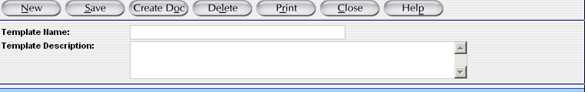
Type “Class Test” for the template name and type “Office supplies for the branch offices” for the description type.
- To save this information as a template for future use, select
- After saving the template select Home to return to the Navigation screen.
- In the IDV Inbox on the main navigation screen, click the Template IDV inbox.
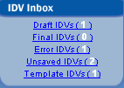
- Select the link to your template by selecting the template name you created.
- At the top of the screen, select . The form is now ready to have information added to it.

Finalize an IDV
- Select the Draft IDV inbox from the main navigation screen. All of the IDVs in draft status will appear in a list format.
- Click on the link for the draft GWAC IDV that you created in the “Create a GWAC” exercise.
- Select the button. The IDV is now in Final status.
- Select the Home button to return to the main navigation.
- Select the Final IDV inbox. The IDV you just approved is now located there.

Make a Correction to a Final IDV
- Select the Final IDVs inbox from the main navigation screen. All of the IDVs in final status will appear in a list format.
- Click the link for the final IDV that is a GWAC.
- When the contract appears, select from the menu bar at the top.
- Scroll down to the Contract Data.
- Type of Contract – From the dropdown menu, change this to “Fixed Price Award Fee.”
- Select . The IDV has now been corrected.

Transactions/Modifications

This Transaction/Modification function is designed to provide quick access for users to make changes to existing Awards and IDVs. This function opens the Award and IDV documents in a Correct or Modify status.

General Functions of Transactions/Modifications
The three general functions of the Transaction/Modifications section are:
- Corrections
- Voids
- Modifications

Corrections
The Correct function allows you to correct an existing Award or IDV in FPDS-NG. Corrections are performed when an error or mistake has been made which does not change the intent of the contract. The fields available for correcting can change without modifying the contract. The Award/IDV must have a Final status in order to use the correct function. Figure 37 shows an example of the search screen for a correction.
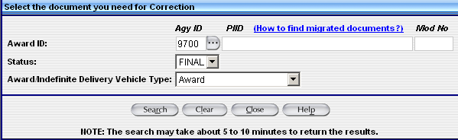
Figure 37. Correction Search Screen
Steps:
From the Navigation screen, under Transaction/Modifications, select.
- FPDS-NG will display the Correction Search screen.
  - Award ID – Enter the Agency ID and PIID.
  - Mod No – Enter the document modification number. If a modification number is not applicable, leave blank.
  - Status – The Final status is selected. Awards/IDVs must be Final to correct the document.
  - Award/IDV Type – Select the appropriate contract type.
Select.
  - FPDS-NG will display a list. Select the document you want to correct from the list.
  - The document is displayed in the correction mode.
  - Make a correction.
When the correction is complete, select to keep all edits.
- Select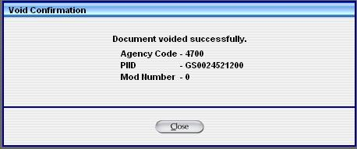. A confirmation box is displayed as a reminder to save the changes.
- Select to return to the Navigation screen.

Modifications
The Modification function allows you to modify an existing Award or IDV with a Final status in FPDS-NG. Figure 38 shows an example of the search screen for a modification.

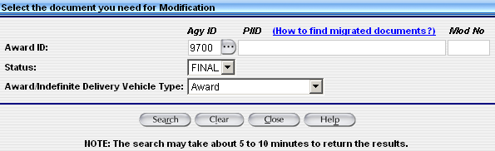
Figure 38. Modification Search Screen
Steps:
- From the Navigation screen, under Transaction/Modifications, select.
- FPDS-NG will display the Modification Search screen.
  - Award ID – Enter the Agency ID and PIID.
  - Mod No – Enter the document modification number. If a Modification number is not applicable leave blank.
  - Status – The Final status is selected. Awards/IDVs must be Final to modify the document.
  - Award/IDV Type – Select the appropriate contract type.
Select.
      - FPDS-NG will display a list. Select the document you want to modify from the list.
      - The document is displayed in the modify mode.
      - Enter the modification number
      - Make a modification.
      - Select a reason for the modification from the dropdown menu.
When the modification is complete, select to keep all edits.
    - Select. A confirmation box is displayed as a reminder to save the changes.
    - Select to return to the Navigation screen.

Exercise: Transactions/Modifications

Correct a Document
From the Navigation screen, under Transaction/Modifications, select.
- FPDS-NG will display the Correction Search Screen.
  - Award ID – Enter “4740.”
  - PIID – Enter the PIID for the GWAC you created .
  - Mod No – Leave blank. This document does not have a modification number.
  - Status – The Final status is selected.
Award/IDV Type – Select IDV. Select.
- FPDS-NG will display a list. Select the document for correction by selecting the link.
- FPDS-NG will display the document in the correction mode.
Under the heading Purchaser Information, selectnext to the Contracting Office ID field.
  - Select to create a new search screen.
Select and change the existing Contracting Office ID from “DT000” to “DD000.”
  - Select the radio button for the Office ID “DD000” with the office name “GSA/PBS.”
Select to add the correction to the document.
When the correction is complete select to keep all edits.
  - Select. A confirmation box is displayed as a reminder to save the changes.
- Select to return to the Navigation screen.

Modify a Document
- From the Navigation screen, under Transaction/Modifications, select.
- FPDS-NG will display the Modification Search Screen.
  - Award ID – Enter “4740.”
  - PIID – Enter the PIID for the Purchase Order you created.
  - Mod No – This will be the first modification number for this document. Leave this field blank.
  - Status – The Final status is selected. Awards/IDVs must be Final to modify the document.
  - Award/IDV Type – Select Award.
Select.
- FPDS-NG will display a list.
      - Select the document link
  - The document is displayed in the modify mode.
  - Mod No – Enter “1.”
  - Reason for Modification –Click the lookup button
  - Select “Close Out” then click .
  - Date Signed – Enter today’s date in MM/DD/YYYY format.
  - Effective Date – Enter today’s date in MM/DD/YYYY format.
  - Completion Date - Enter today’s date in MM/DD/YYYY format.
Select and then.
- Select to return to the Navigation screen.

Reports
The Reports function allows the user to add reports to an inbox called My Reports. The inbox is accessed from the main navigation screen of FPDS-NG. An example of the My Reports inbox is shown below in Figure 39. Once the user selects reports they are stored on this screen for easy access. However, if no reports appear on this screen or the user wishes to add additional reports to their inbox they can use the Add Reports button to do so.
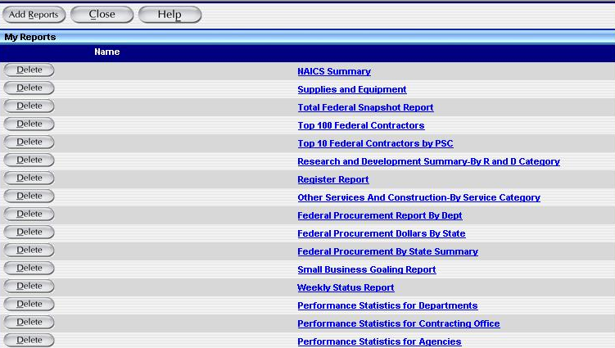
Figure 39. Reports Screen

General Functions of Reports
The functions of the Reports section are:
- Add Reports
- Create Reports
- Accessing Reports in My Reports

Add Reports
Use the following steps to add reports if you are a government user.

Steps:
- Click on the My Reports icon on the main navigation screen.
- Select the Add Reports option.
- Select the available reports by selecting the associated checkboxes.
- Click the Add to My Reports button. The selected reports will appear in a searchable library called My Reports.

Create Reports
This functionality is coming soon and will enable users to create reports based on their individual needs.

Accessing Reports in My Reports
My Reports inbox stores reports that a user has added or bought. A user must access this screen in order to run a report. Use the following steps to run a report.

Steps:
- Click on the My Reports icon.
- If report titles do not display, refer to the previous sections to add or buy reports according to your user designation.
- When reports are listed in your My Reports screen, select the report you want to display. The search criteria screen for your report appears.
- Enter your report’s search criteria.
- Click the Execute button to produce the report based on the search criteria entered.

